**2. Perform the migration from Mongodb to DocumentDB and RDS MySQL to DocumentDB (Scenario - All Database, Single Database with all tables, Single database with single table )**

**Part 2: Migration from MySQL to DocumentDB**

Step 1:

Create Mysql Instance:

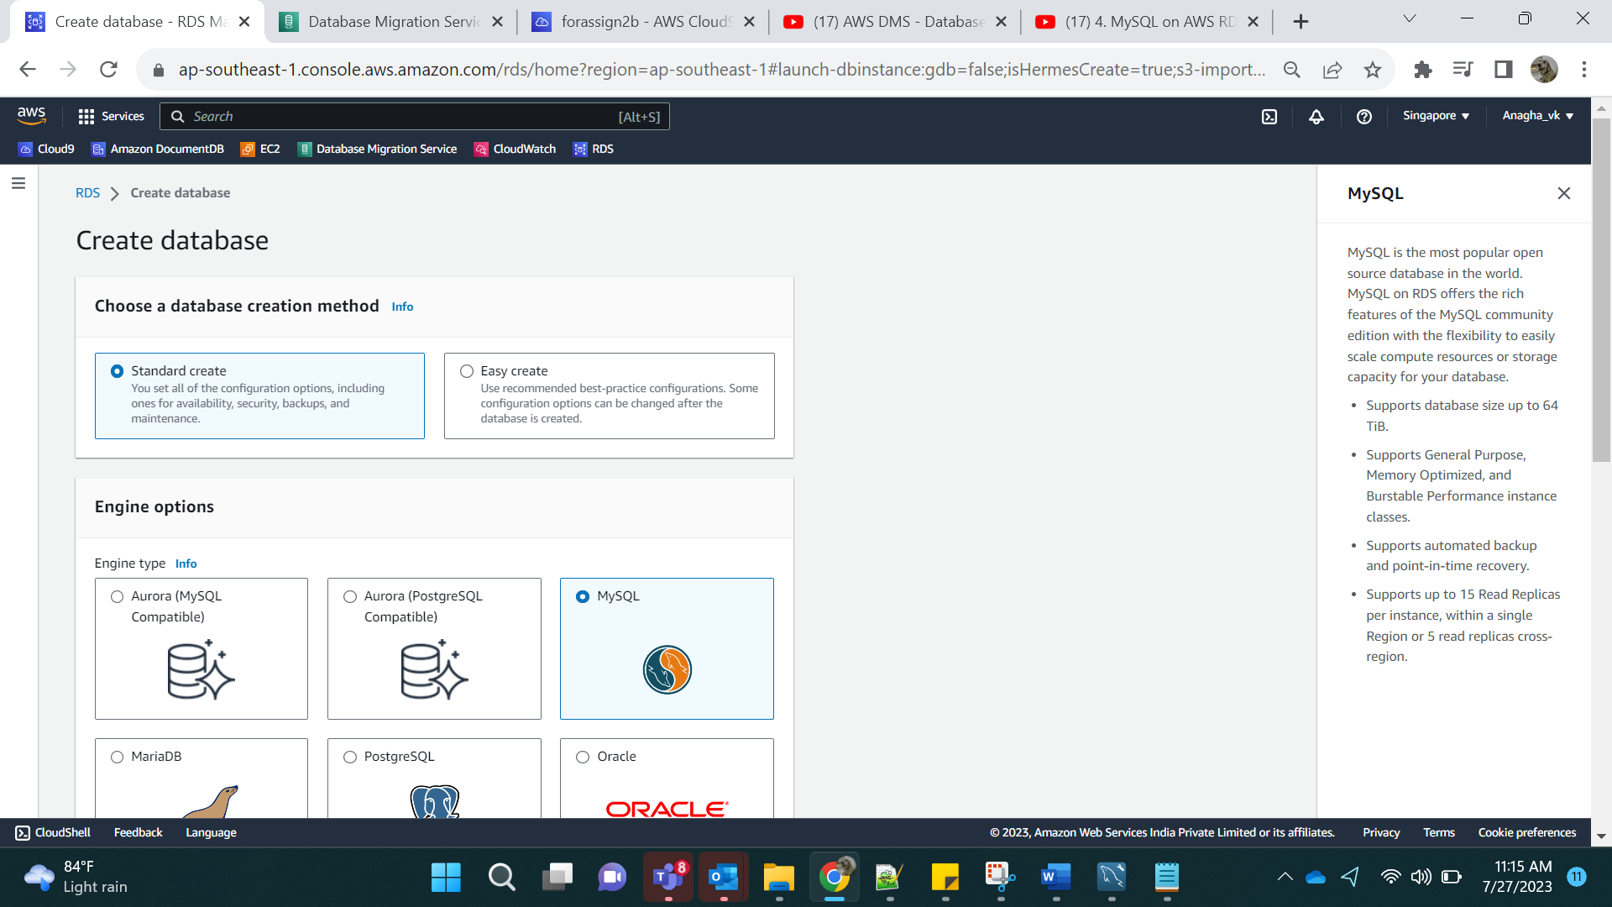

Select free tier:

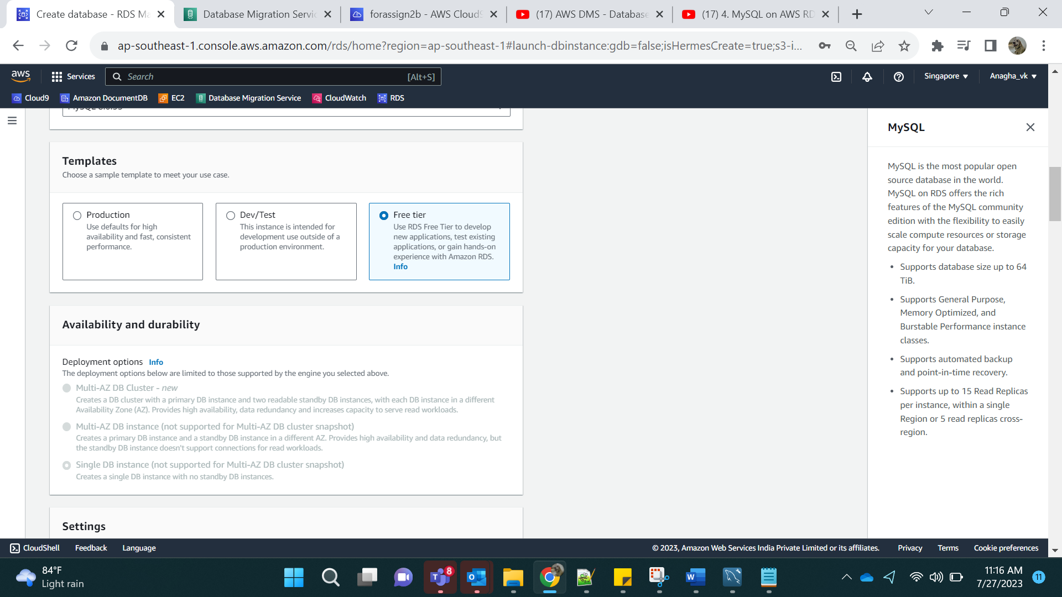

Name: Database -2b

Add password:

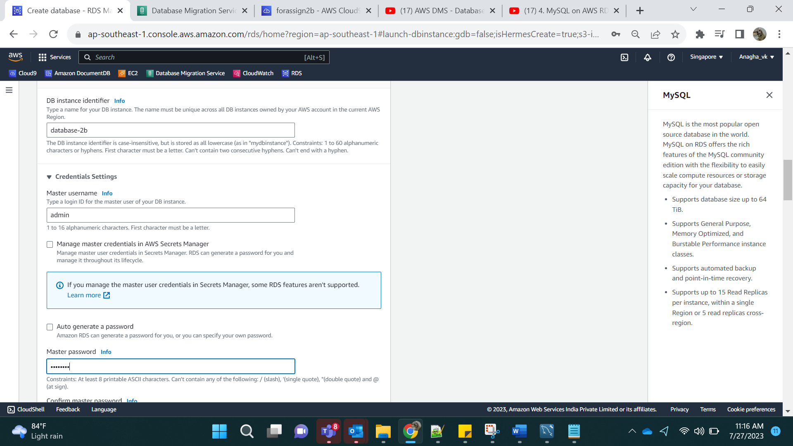

Confirm the password and select the minimal instance configuration:

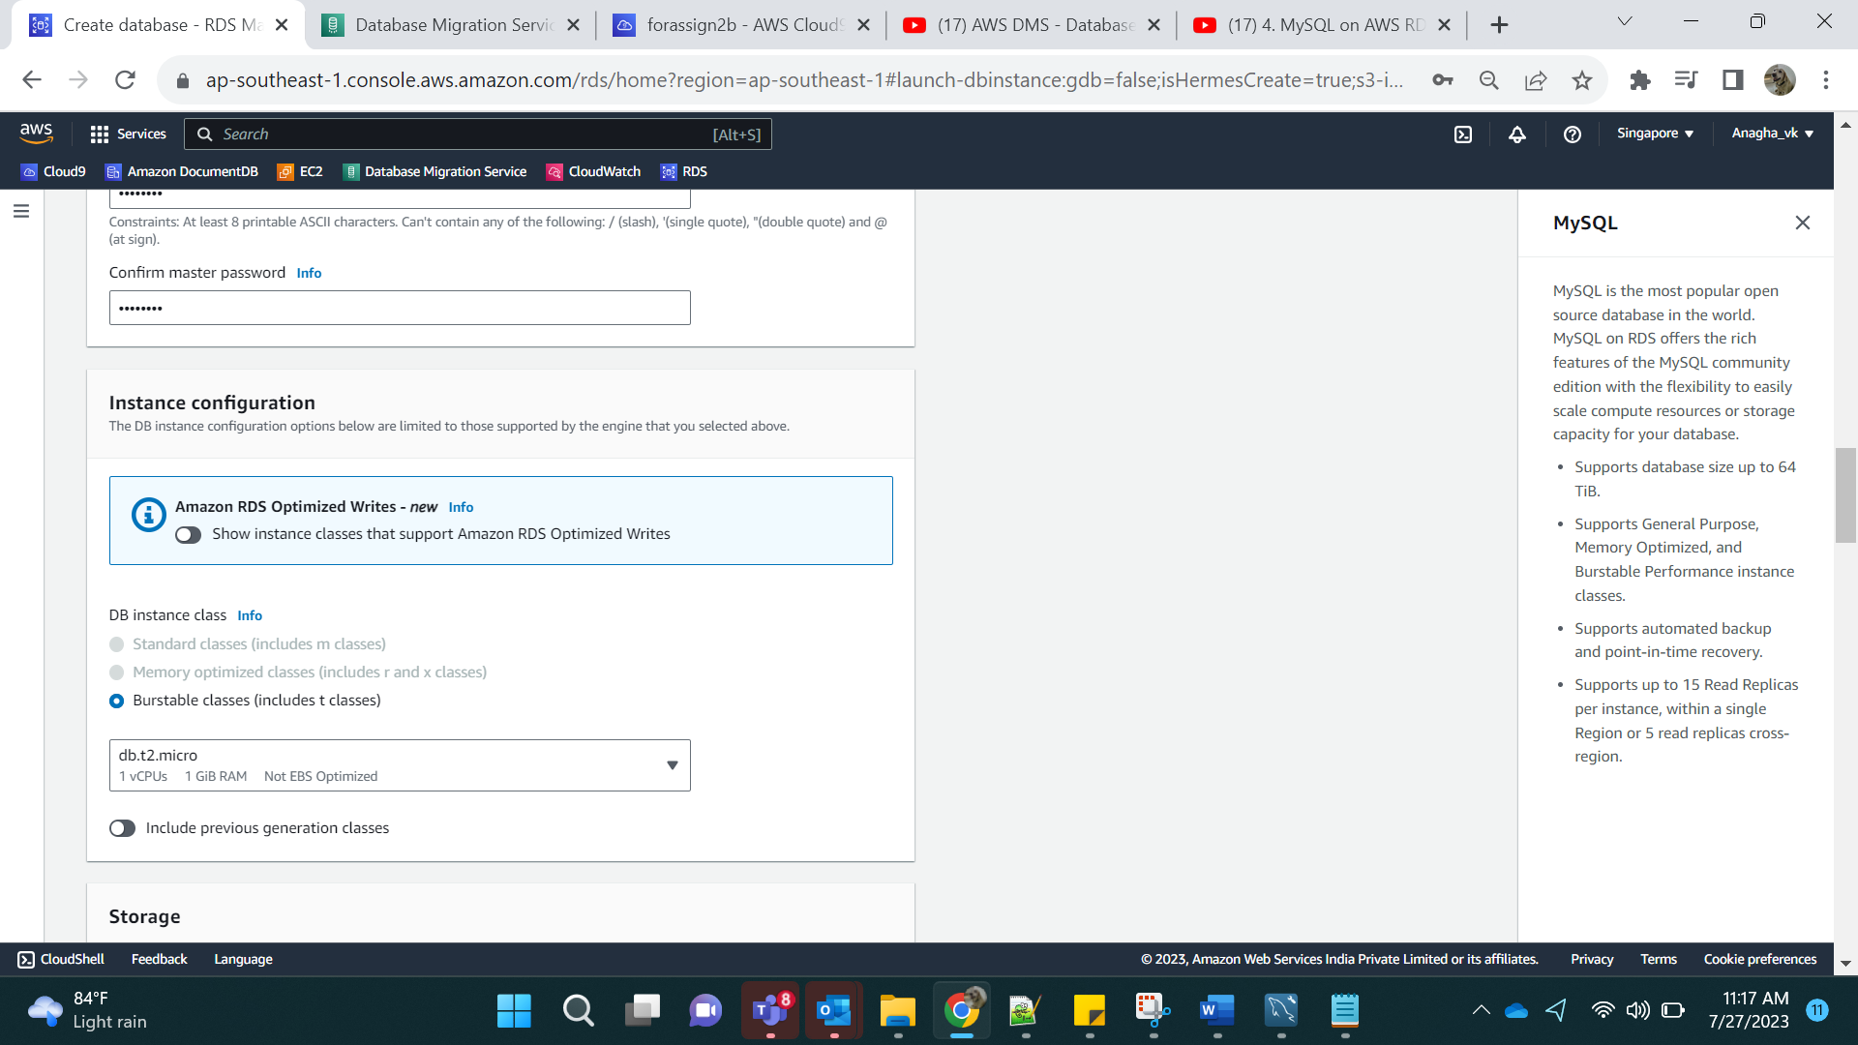

Click on yes for Public access

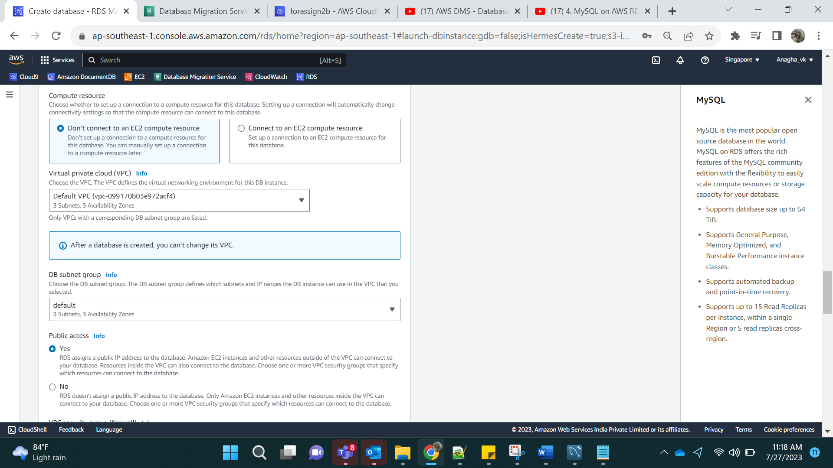

Click on-> Create Database

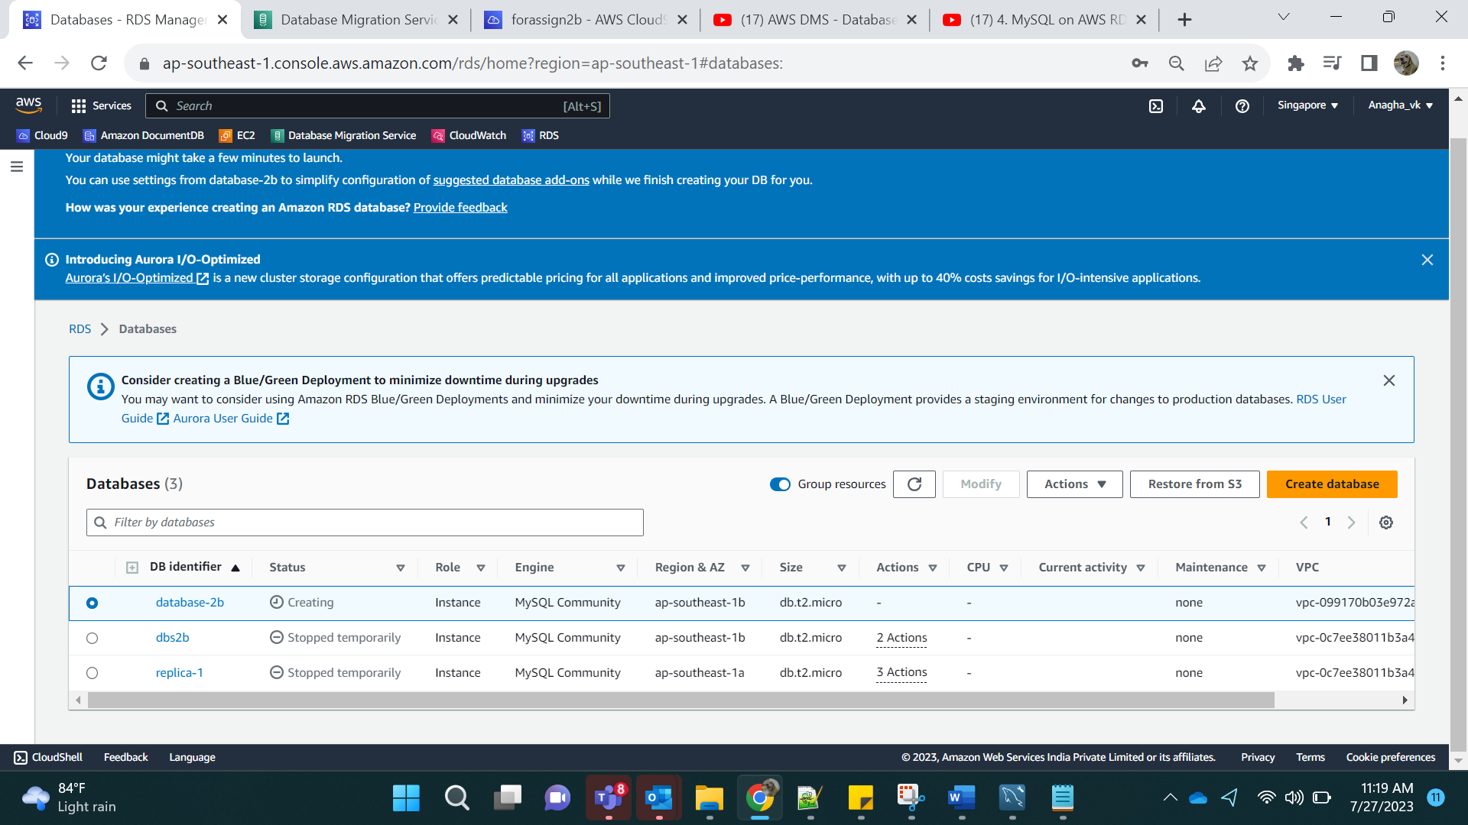

Step 2:

Select the database -> go to Actions and Create Read Replica

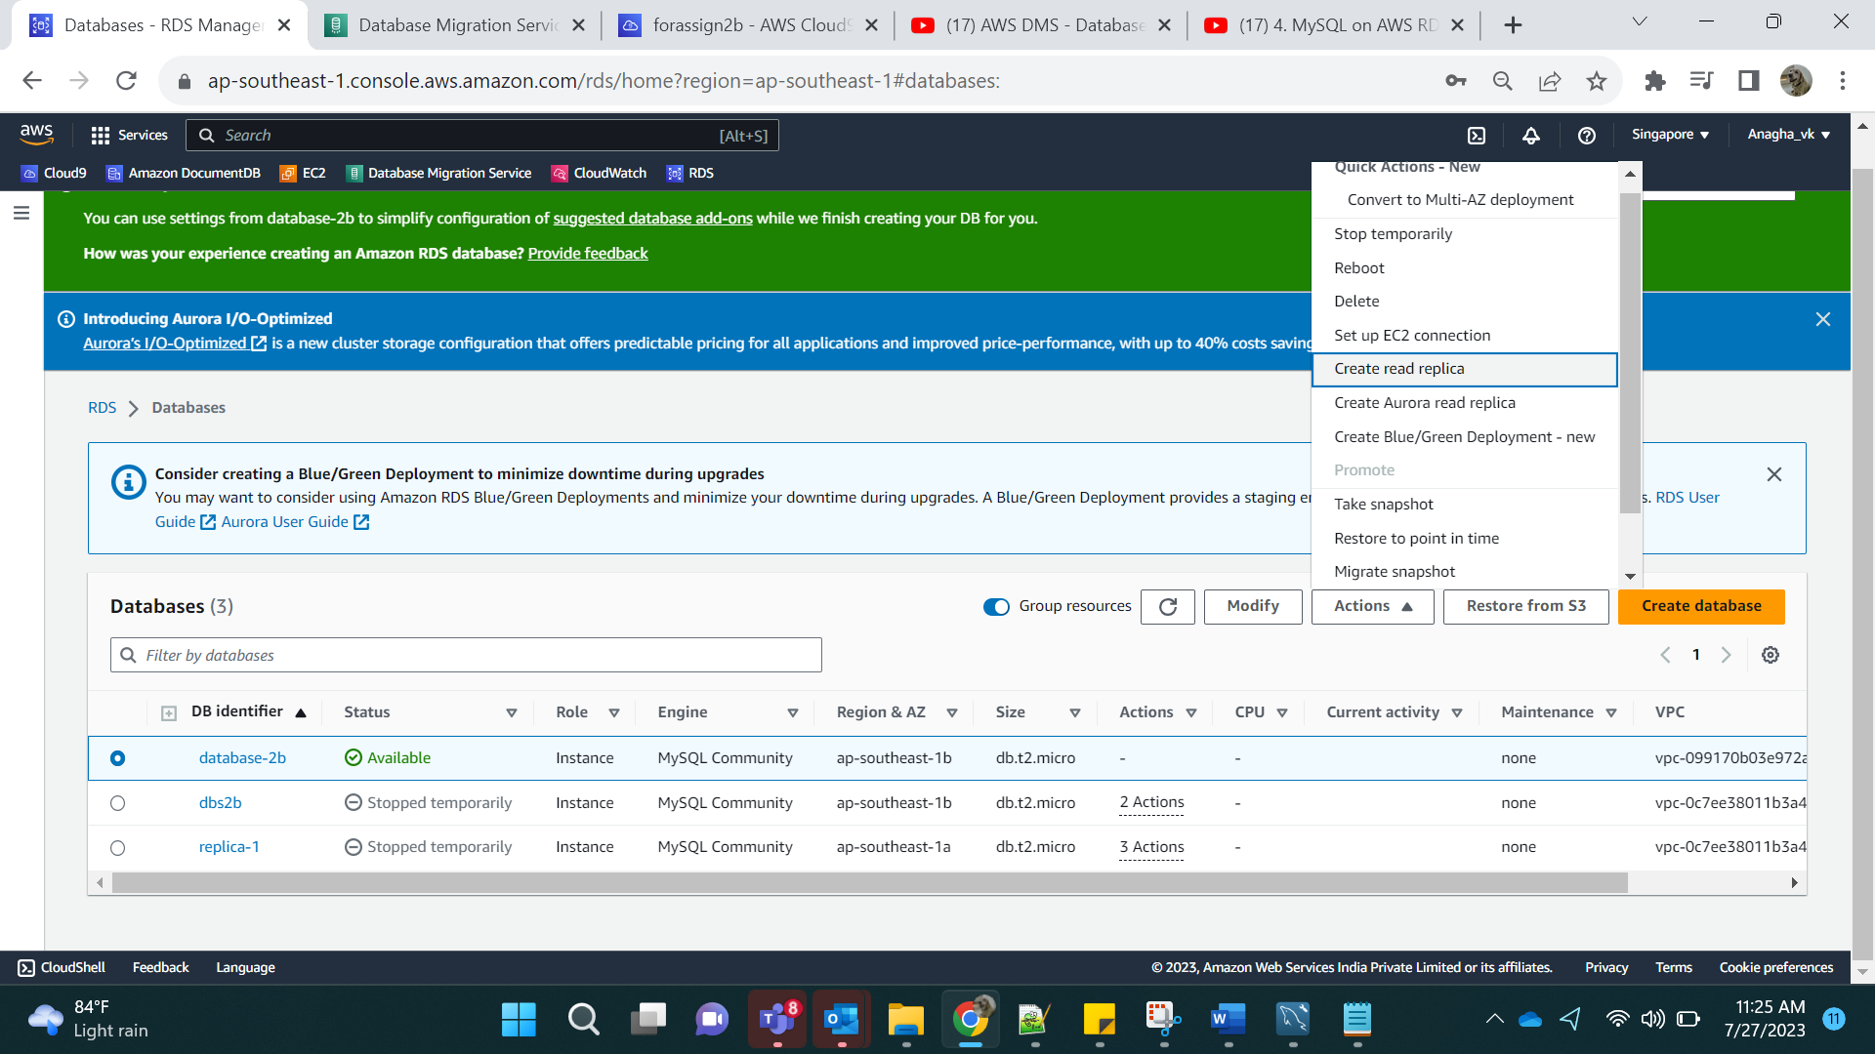

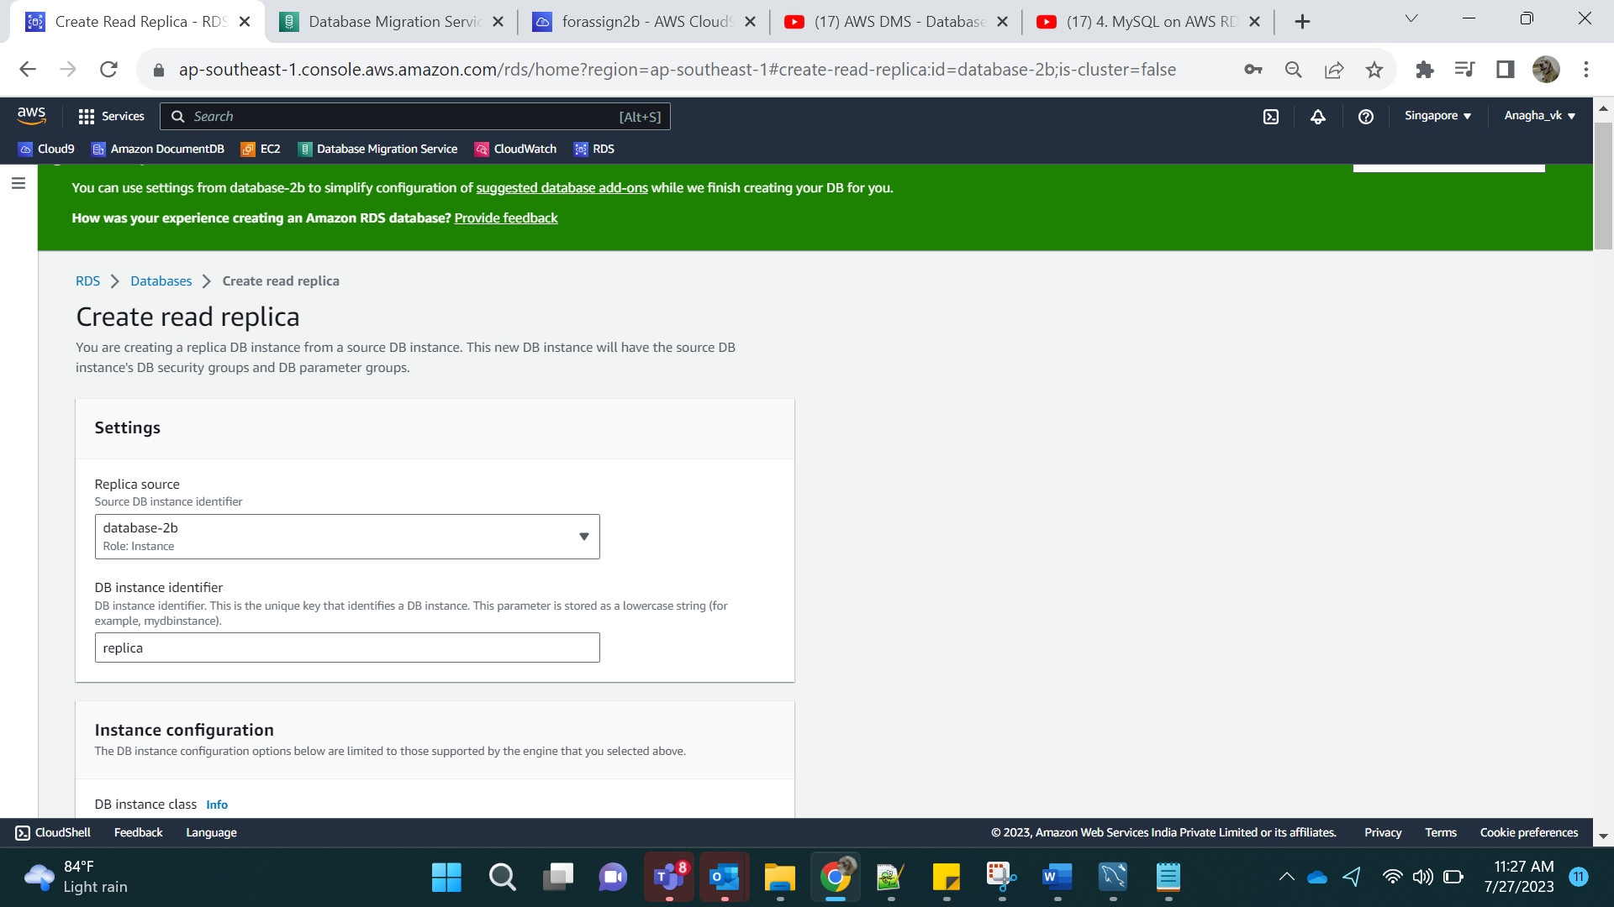

Make it Publicly accessible:

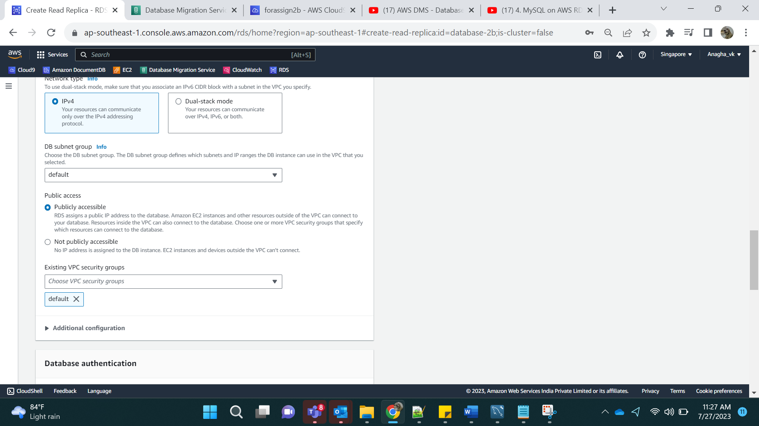

Create read replica.

Result:

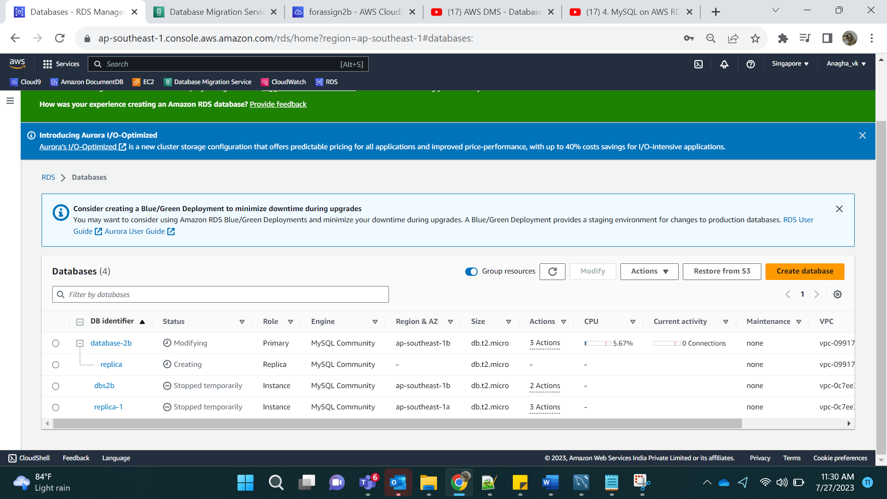

Step 3: [Downloaded from software center]

Go to MYSQL Workbench and test connection for both, Database2b and replica.

Databse2b:

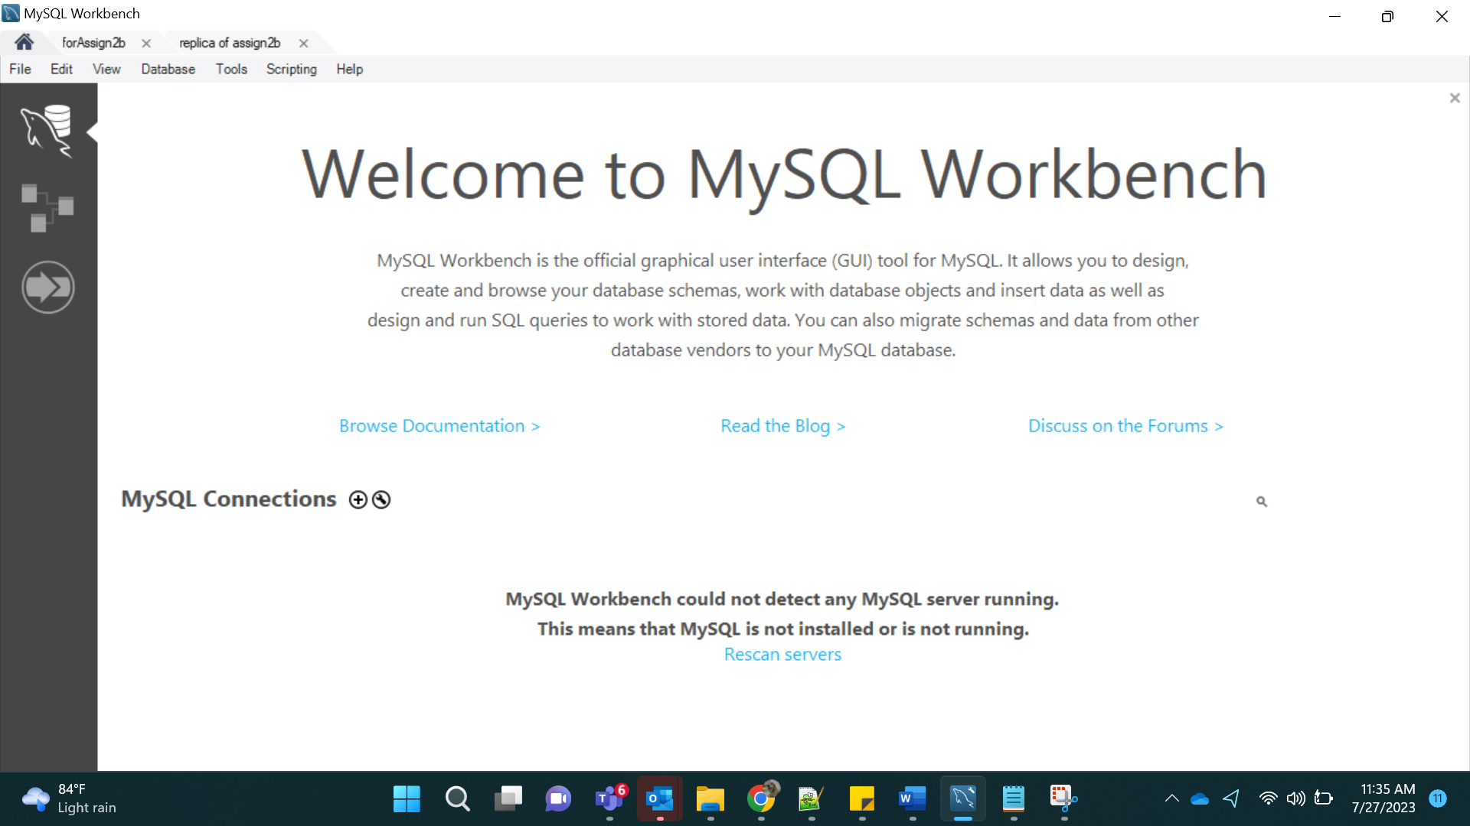

Click on +

Add name and host as the endpoint for database 2b:

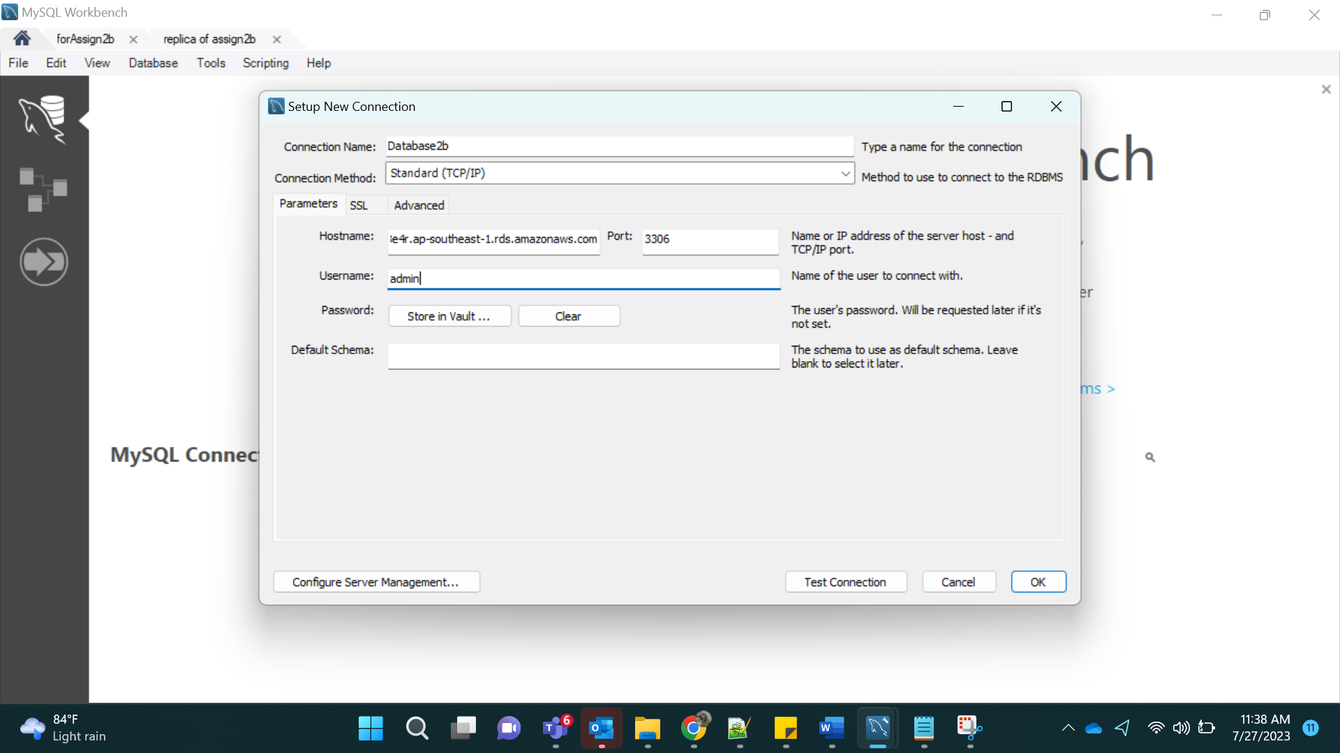

For password, click on store in vault:

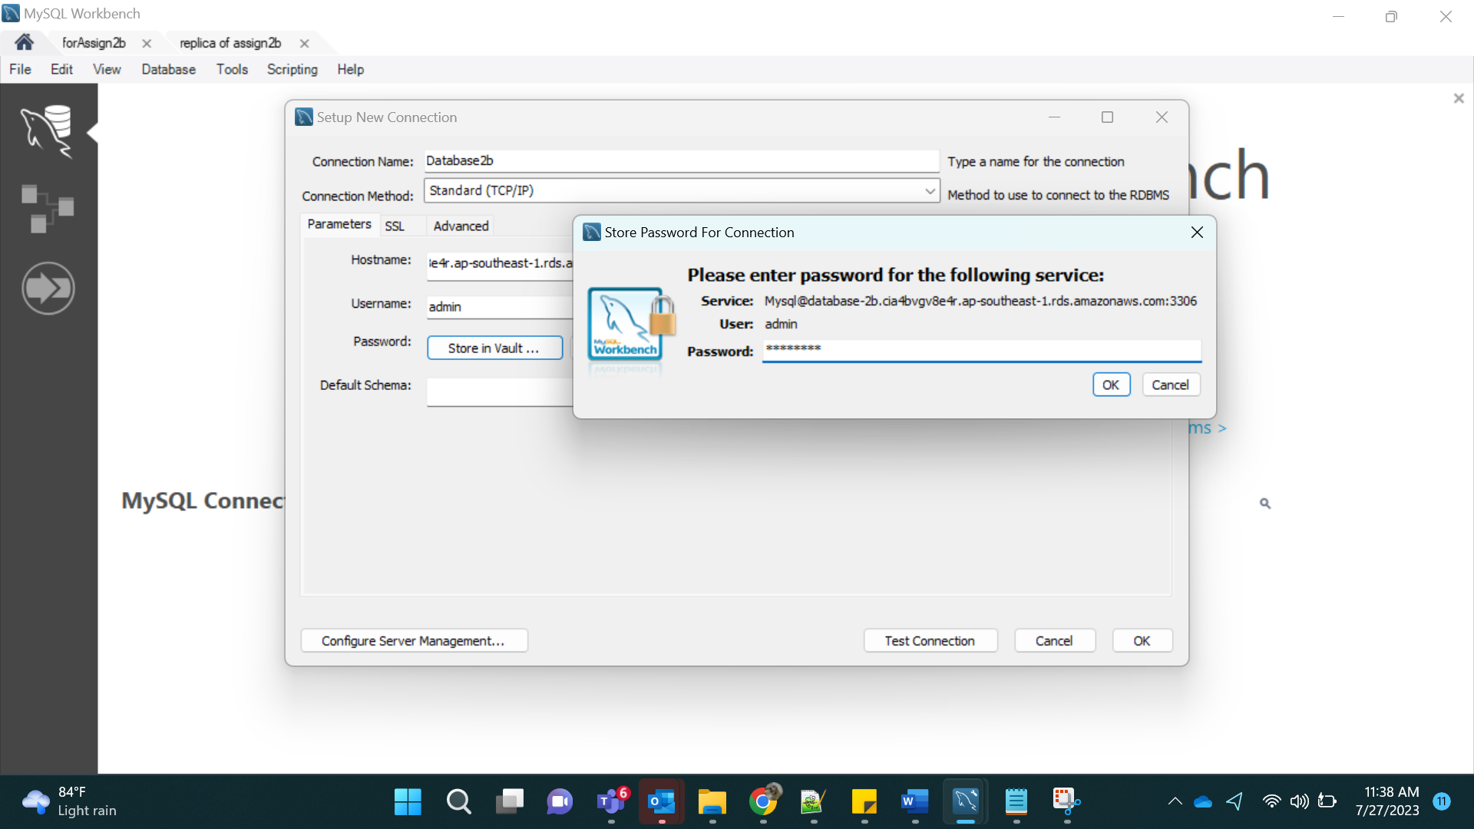

Click on connection

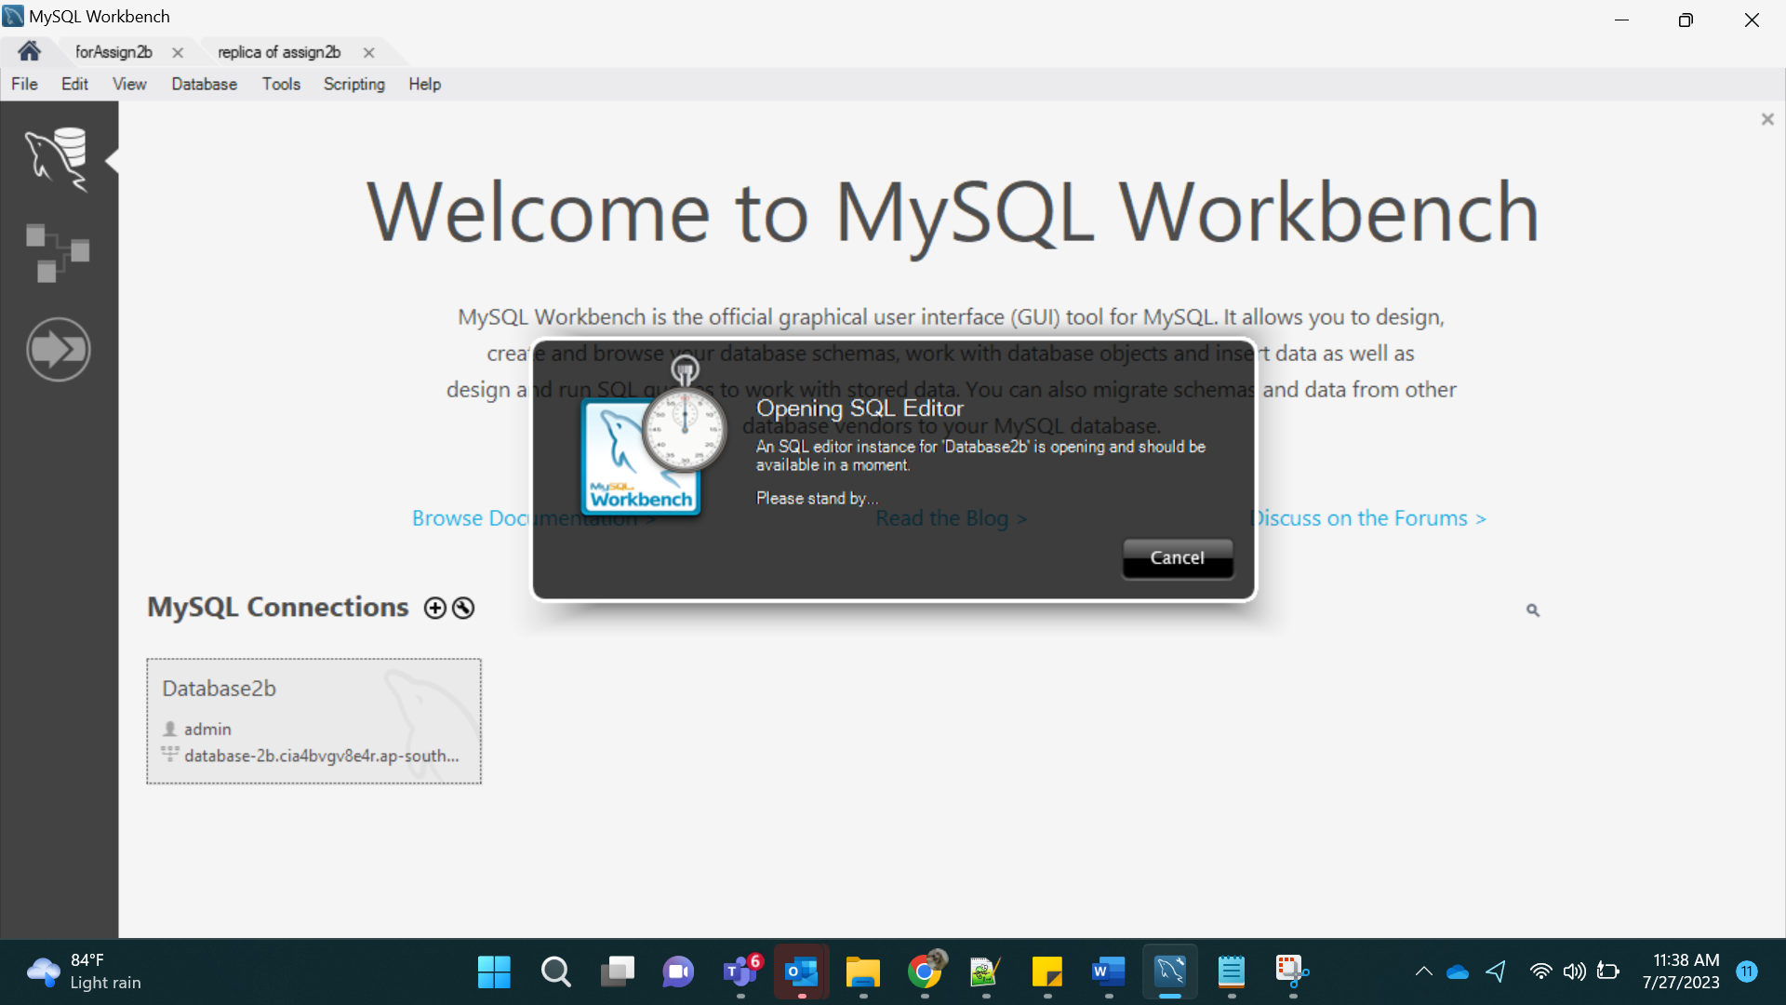

This gave me error, so I added 3306 port to Security group.

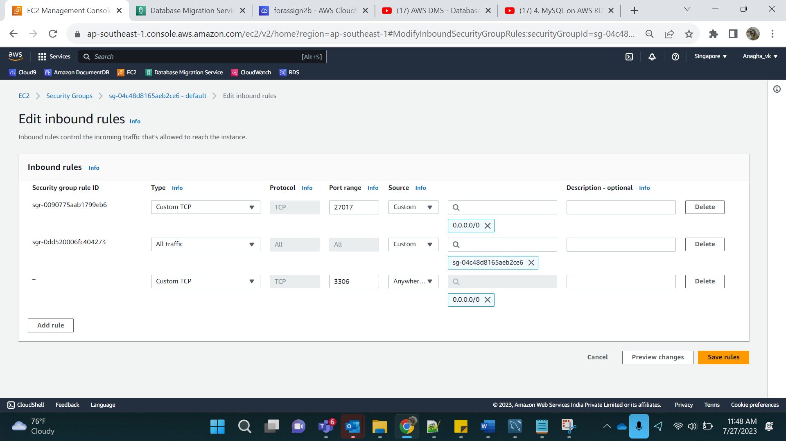

Step 4:

On successful connection, we add data into the MYSQL:

CREATE DATABASE LIBRARY;

use LIBRARY;

CREATE TABLE IF NOT EXISTS books (

book_id INT,

title VARCHAR(255) NOT NULL,

publish_date DATE,

description TEXT,

PRIMARY KEY (book_id)

);

INSERT INTO books(book_id,title,publish_date, description)VALUES (1,'Learn MySQL', CURTIME(),'this is a book on mysql');

INSERT INTO books(book_id,title,publish_date, description)VALUES (2,'Learn Oracle', CURTIME(),'this is a book on oracle');

INSERT INTO books(book_id,title,publish_date, description)VALUES (3,'Learn SQL Server', CURTIME(),'this is a book on SQL Server');

INSERT INTO books(book_id,title,publish_date, description)VALUES (4,'Learn DB2', CURTIME(),'this is a book on DB2');

INSERT INTO books(book_id,title,publish_date, description)VALUES (5,'Learn Aurora', CURTIME(),'this is a book on amazon Aurora');

create table couples

(

cpl_no varchar(5),

name varchar(25) Not NULL,

PRIMARY KEY(cpl_no)

);

insert into couples values('1a','Gaurav');

insert into couples values('1b','Anagha');

insert into couples values('2a','Jaya');

insert into couples values('2b','Sonu');

insert into couples values('3a','Arpita');

insert into couples values('3b','Abhishek');

create database db2;

use db2;

create table building

(

bld_id INT(3),

name varchar(25) Not NULL,

PRIMARY KEY(bld_id)

);

insert into building values('1','CP');

insert into building values('2','Zephyr');

insert into building values('3','Whispering Winds');

insert into building values('4','Astha');

insert into building values('5','Totara Park');

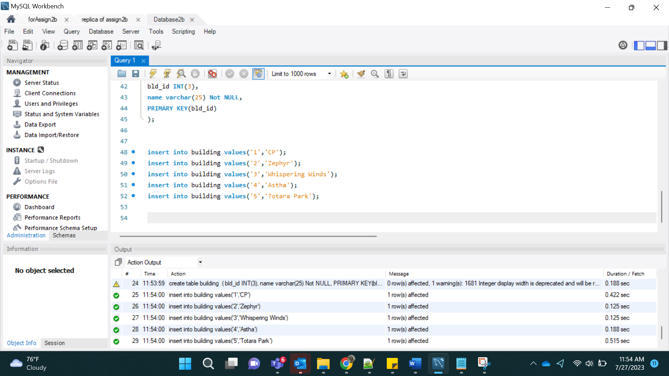

For Replica:

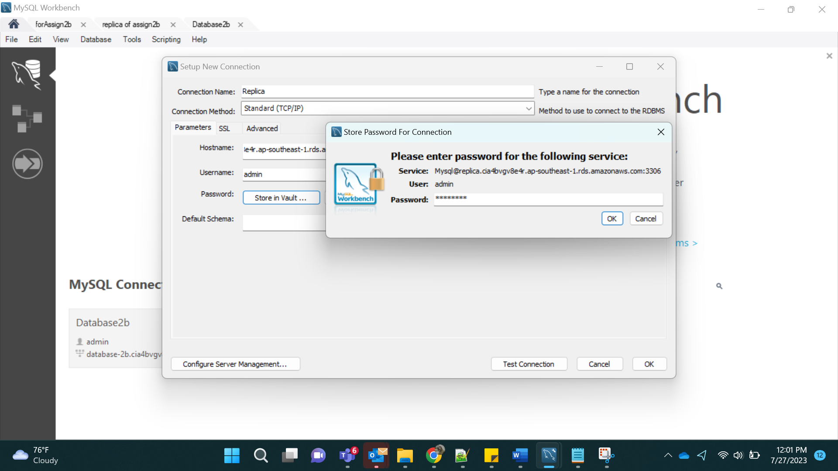

On checking Replication:

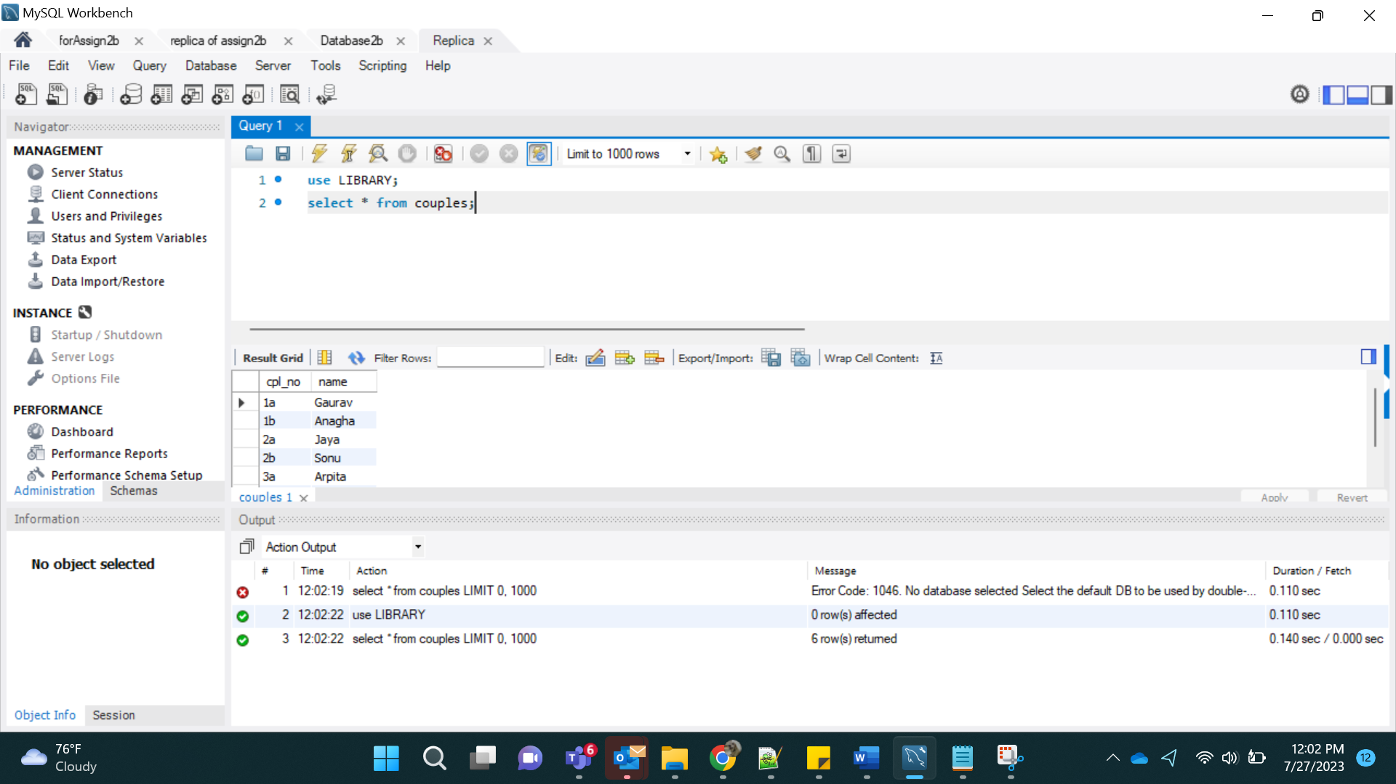

Step 5:

Creating for DocumentDB:

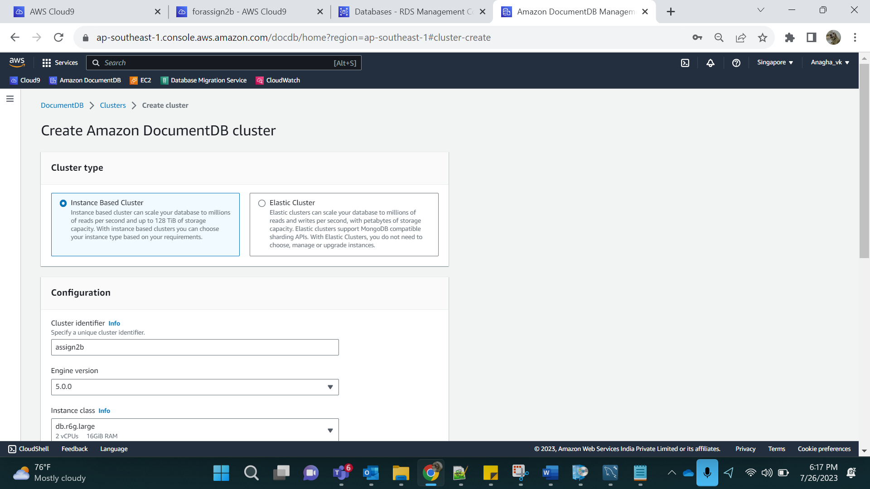

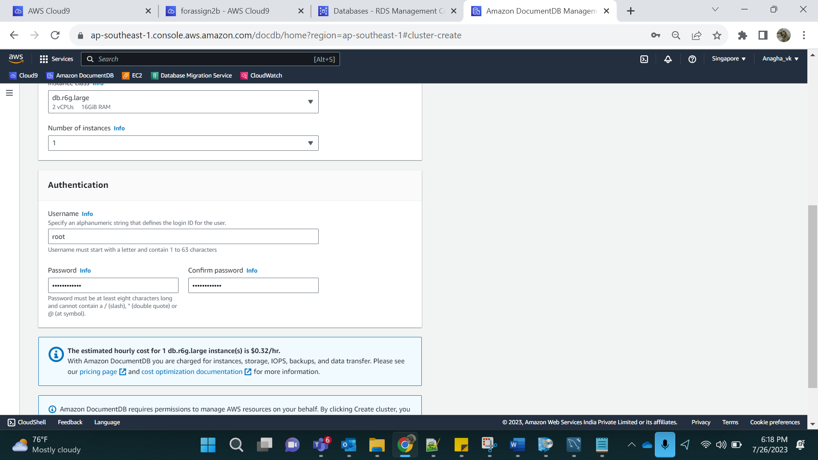

Result:

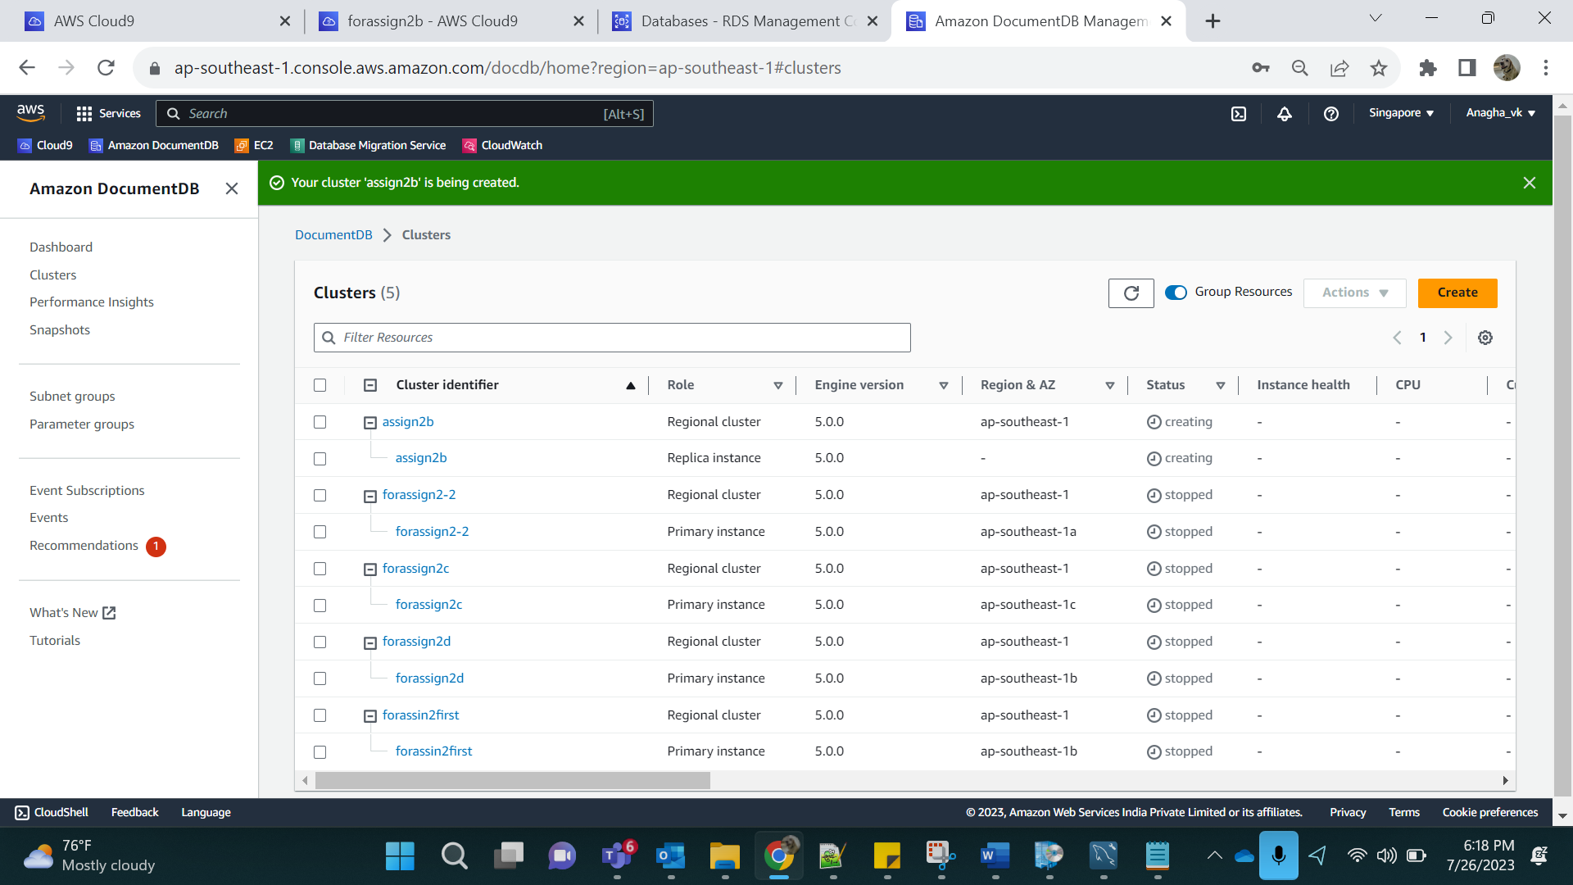

Step 6:

In DMS, create replication Instance:

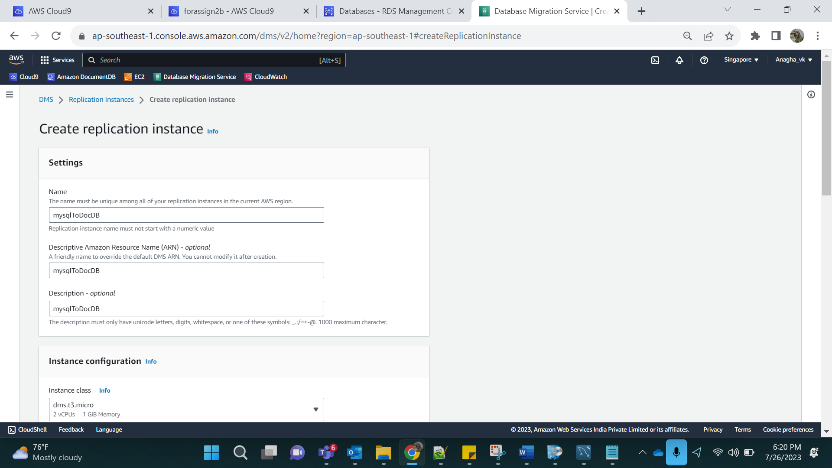

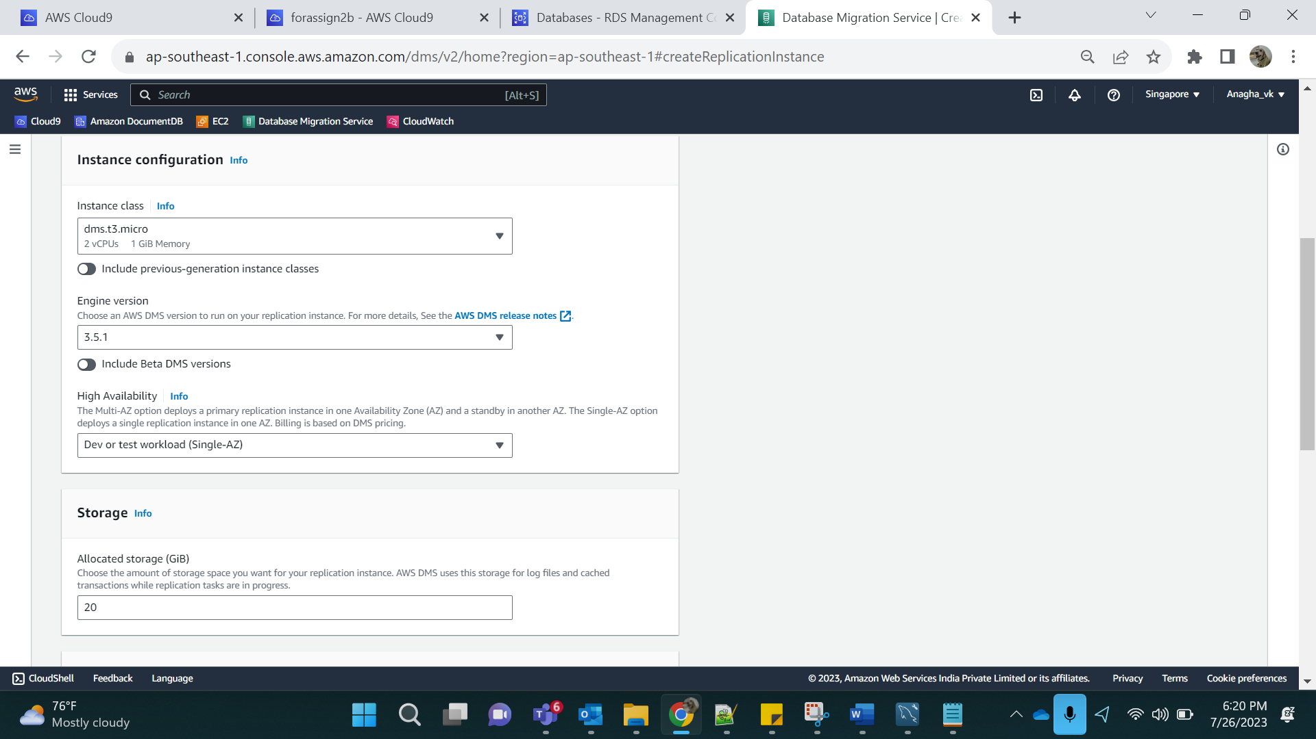

Step 7:

EndPoints:

Create source and target.

1)source

Select on Select RDS DB instance.

Select Database-2b

Rest data gets loaded on its own.

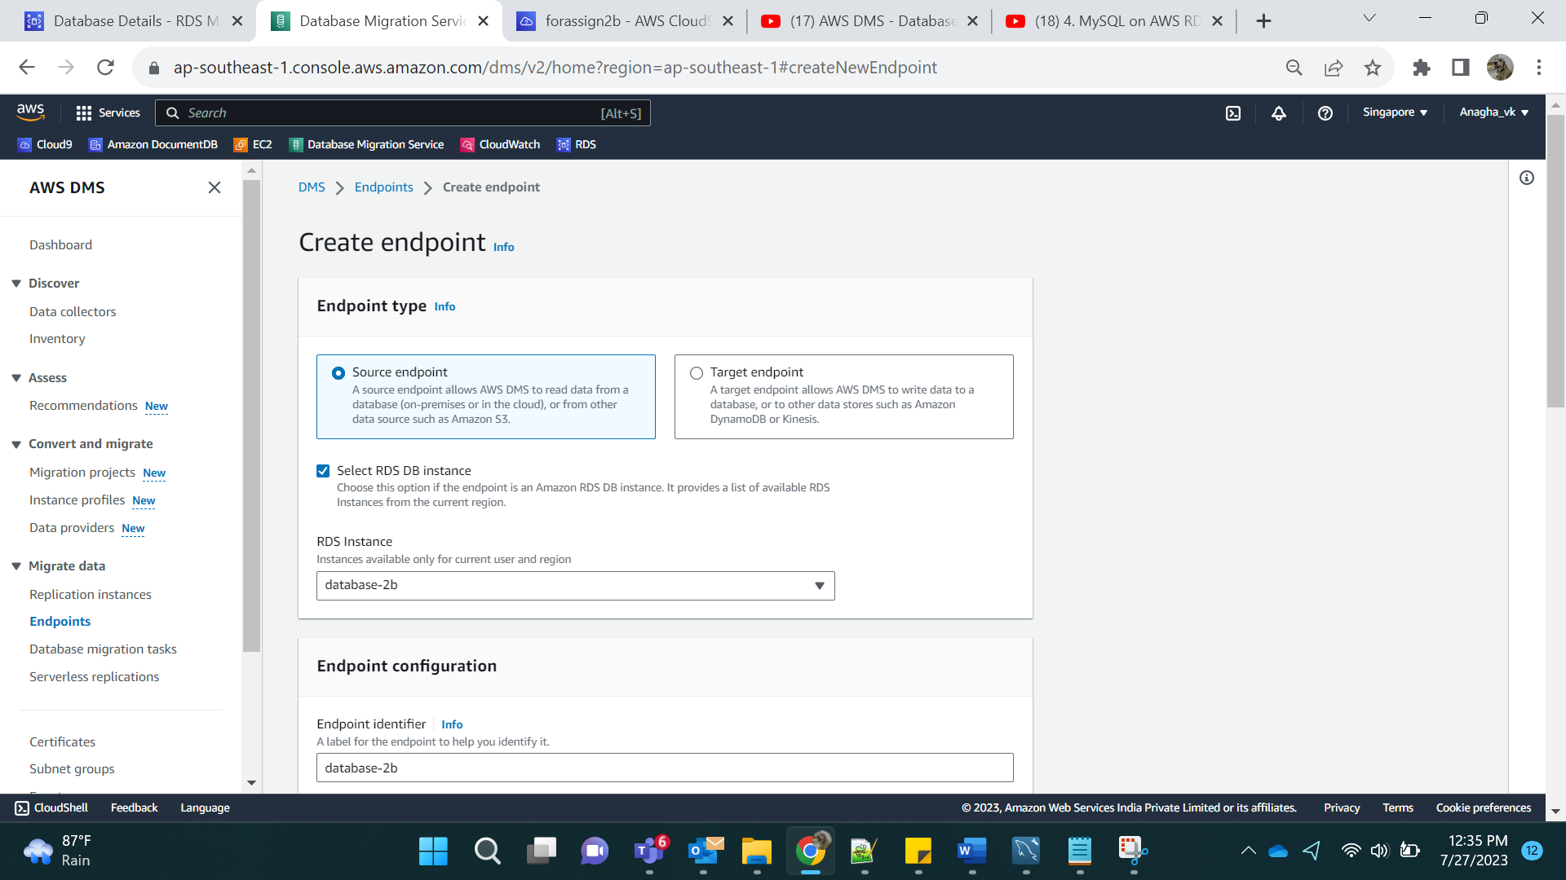

Provide access information manually

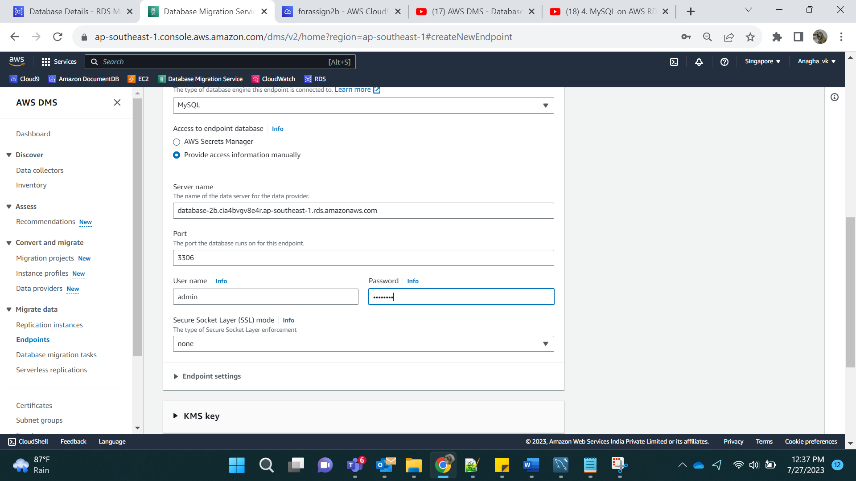

2) target

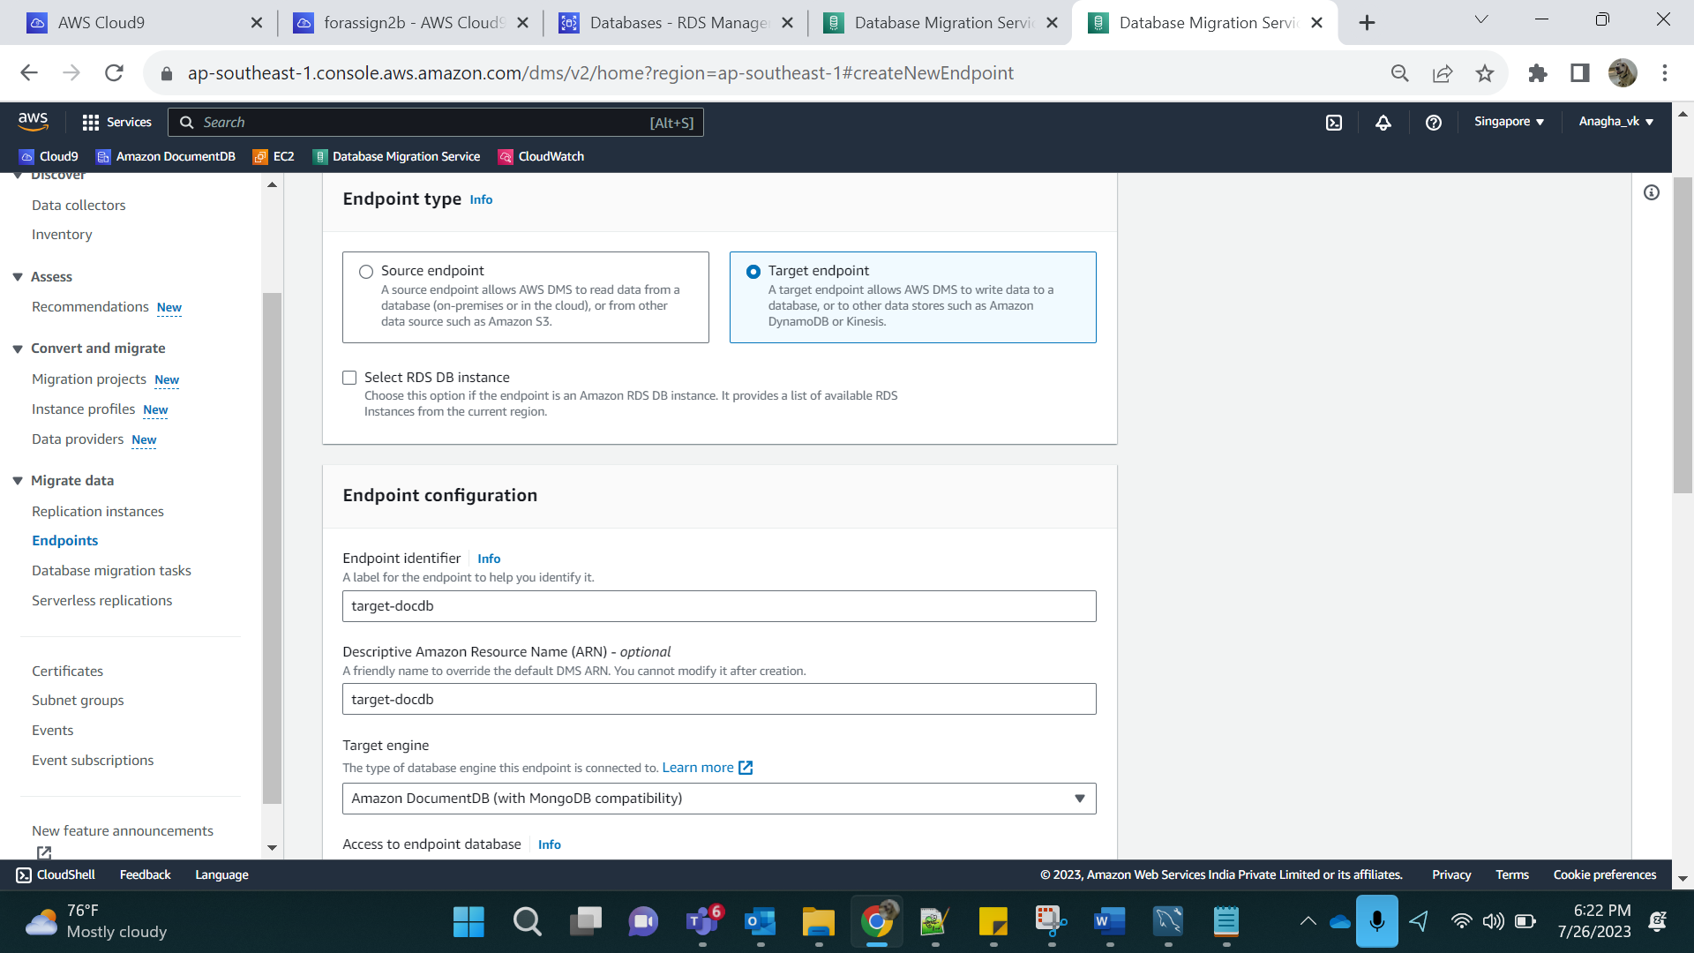

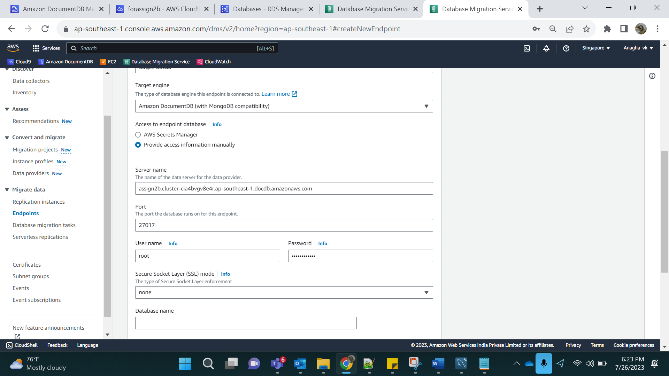

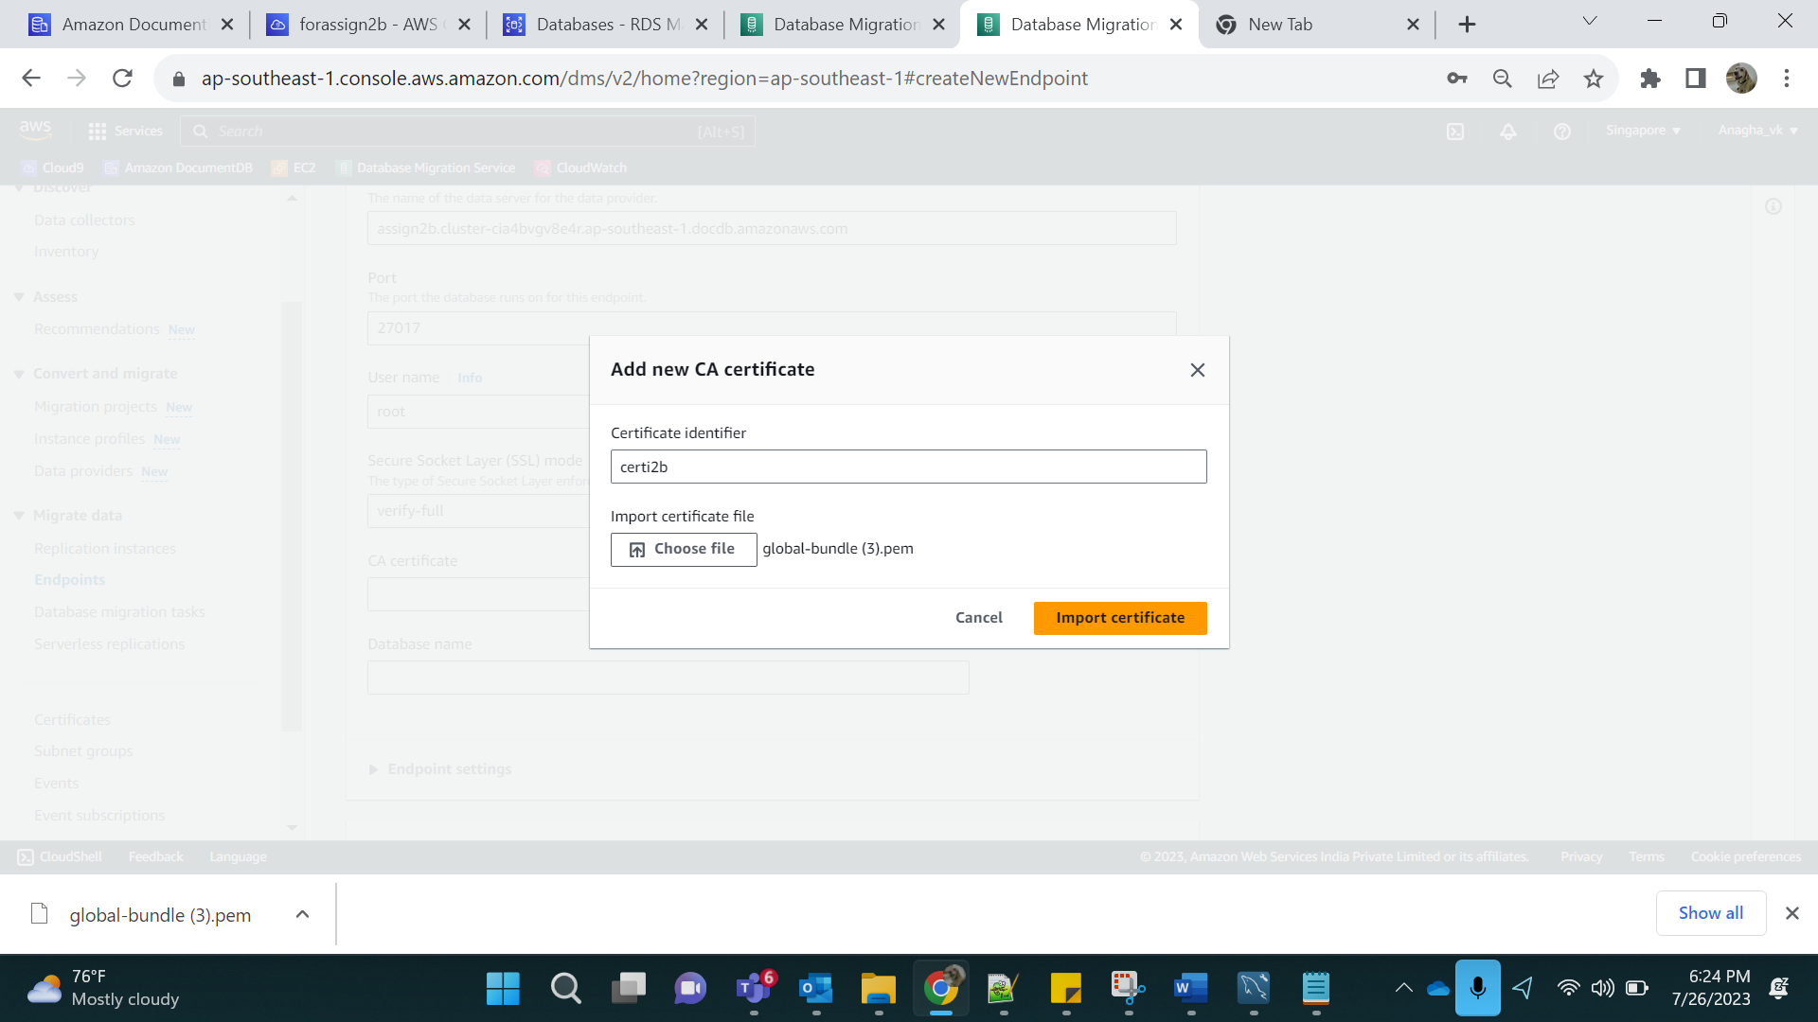

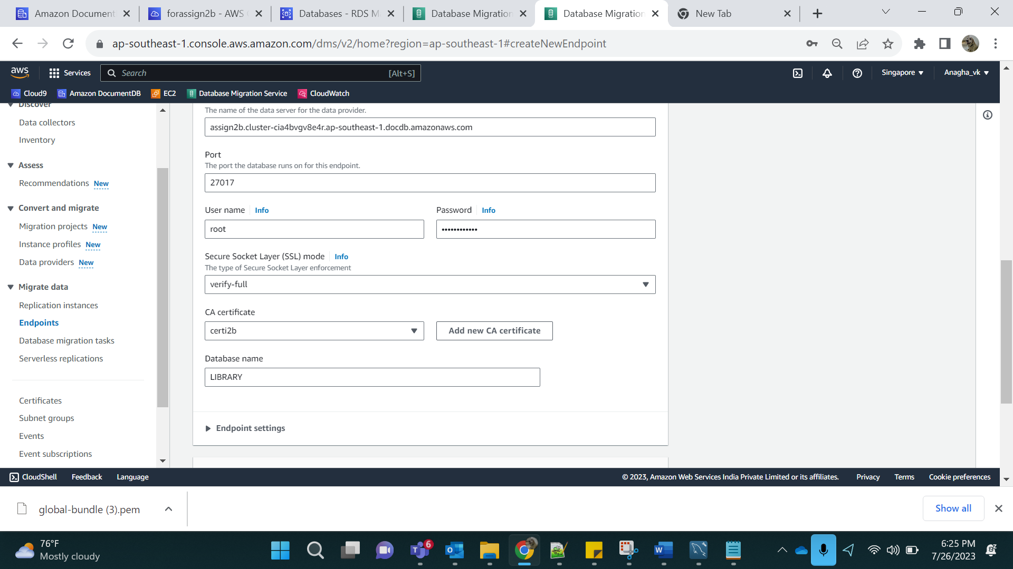

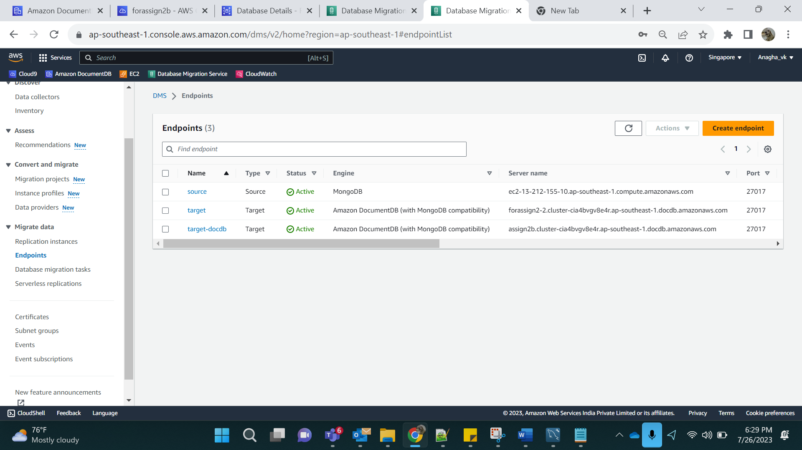

Step 8:

Testing Connection:

Source:

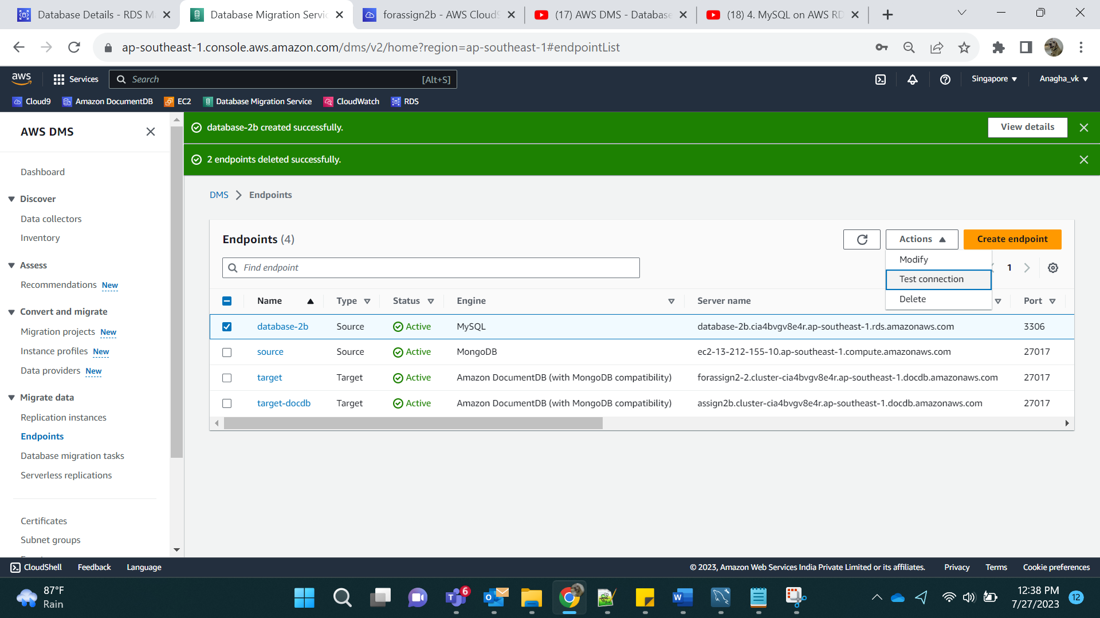

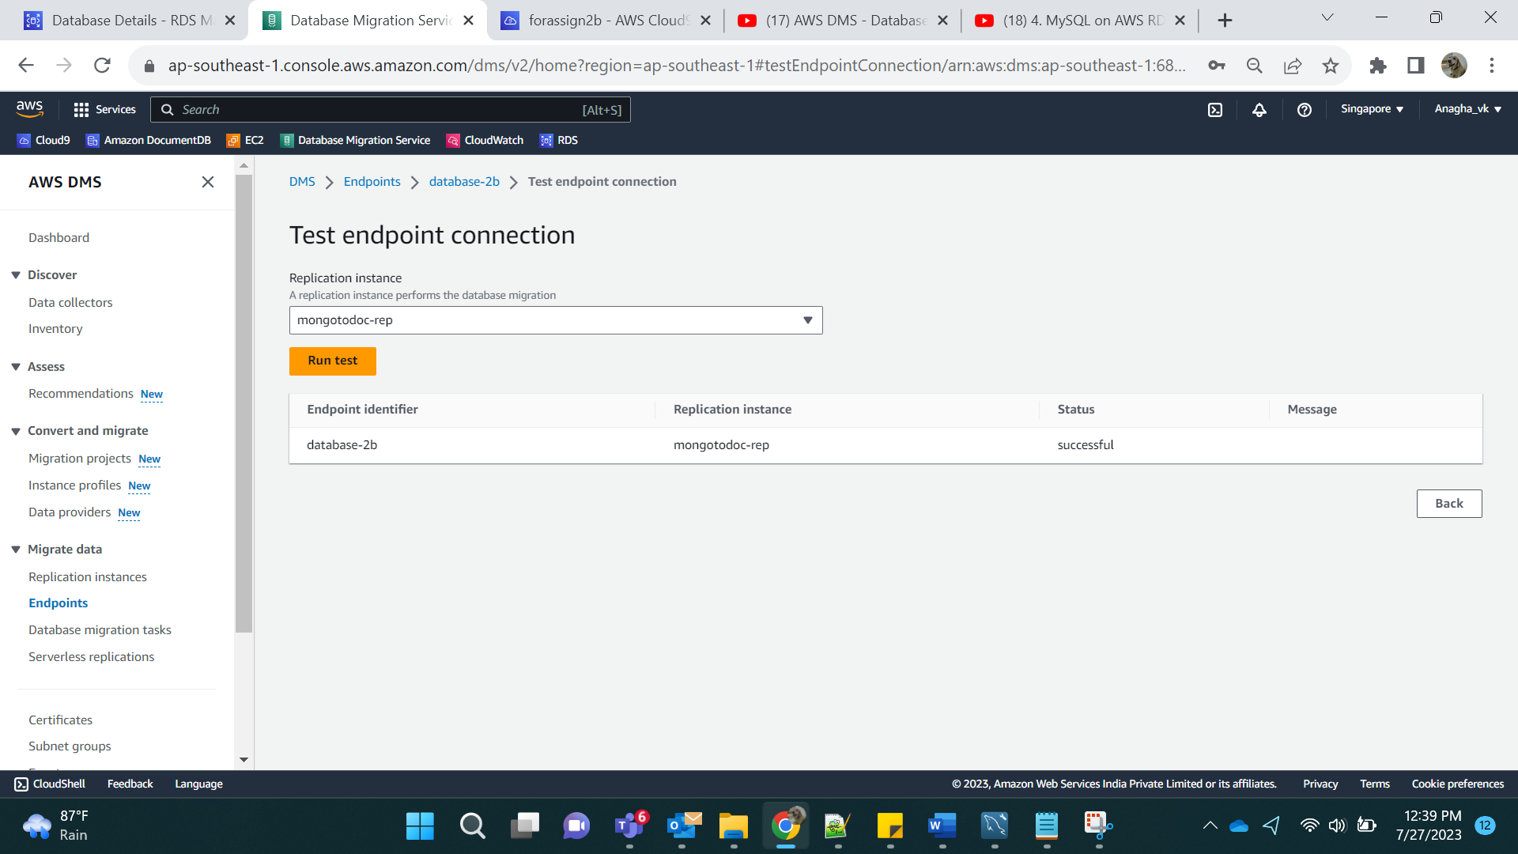

Target:

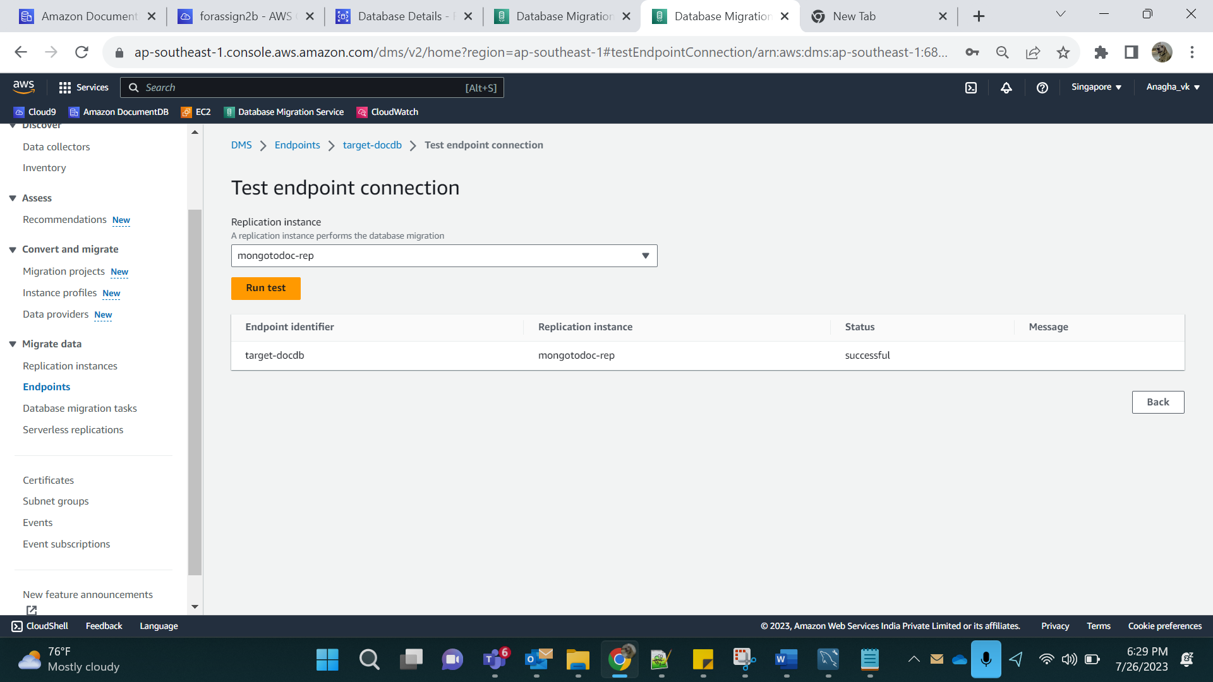

Step 9:

Create Database Migration Service (DMS) Task

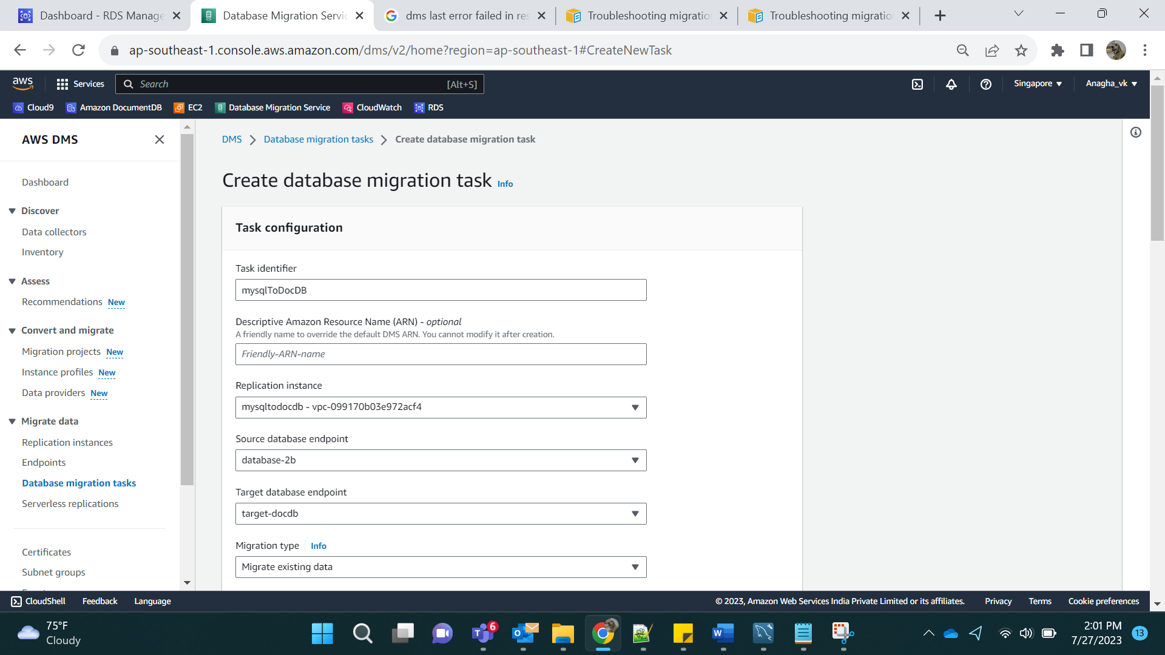

Selection Rules: use 1 database, all tables

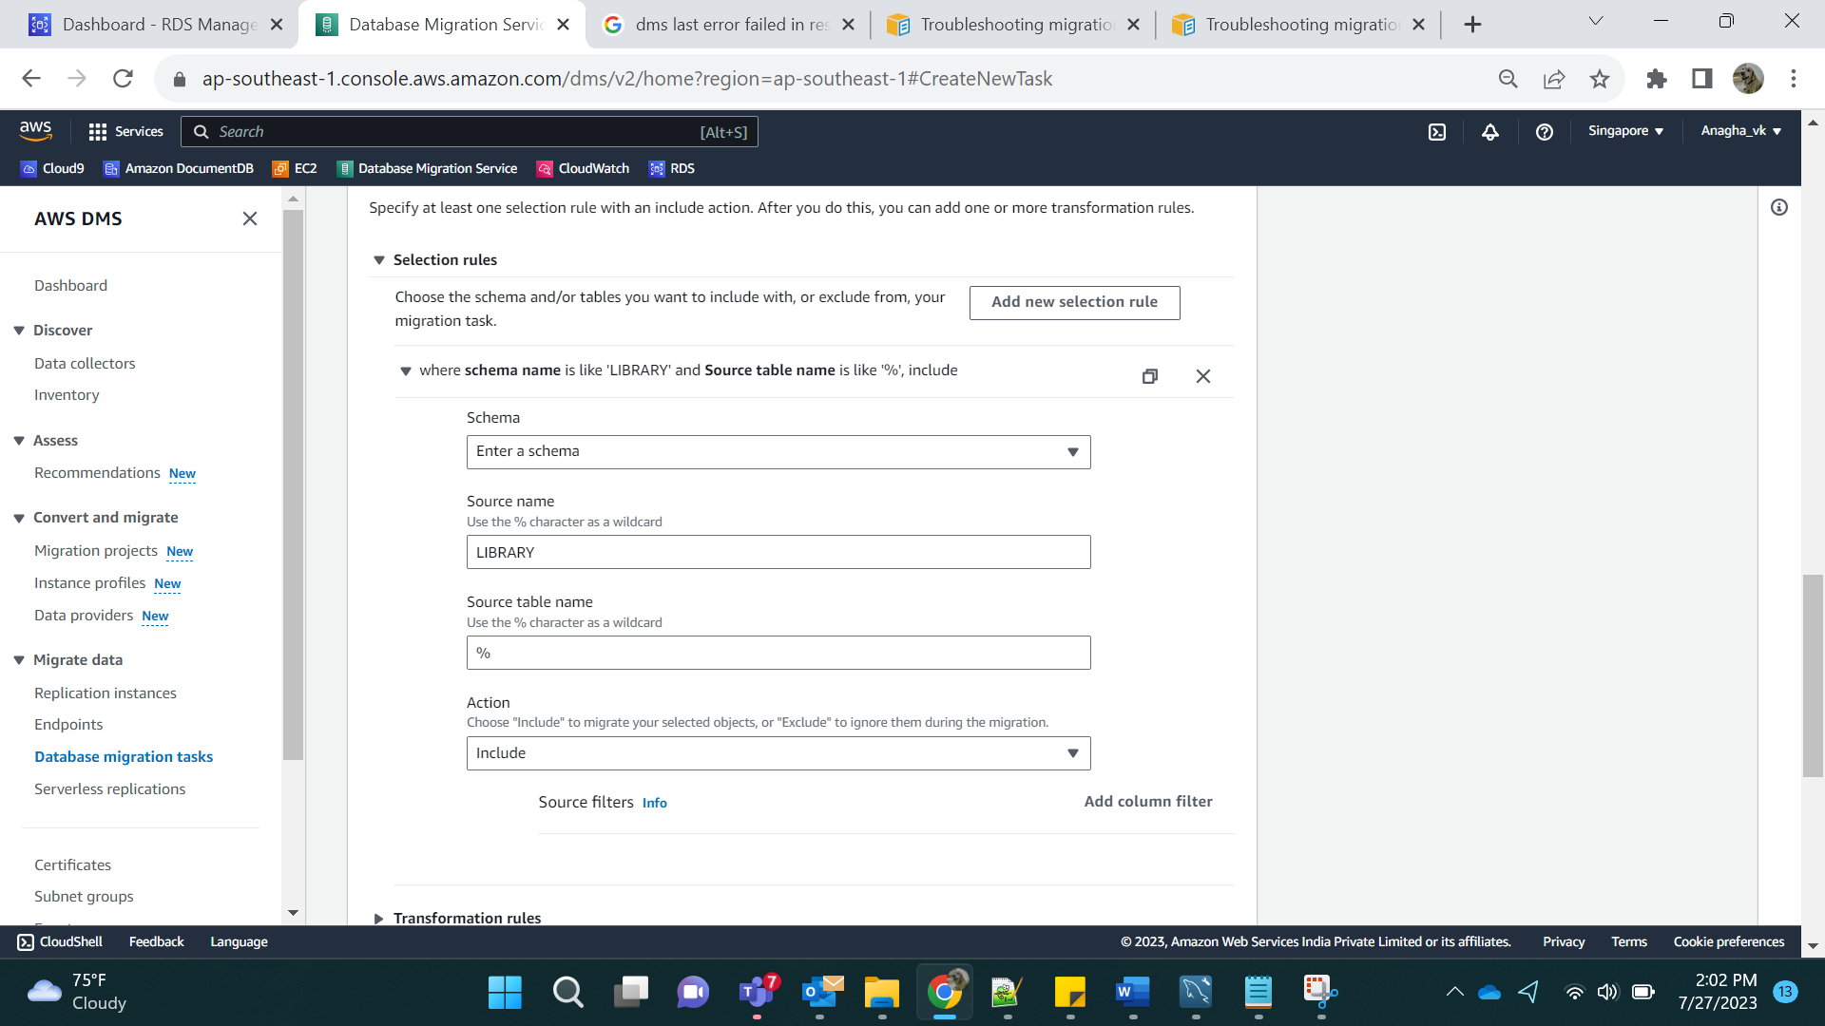

Click on create:

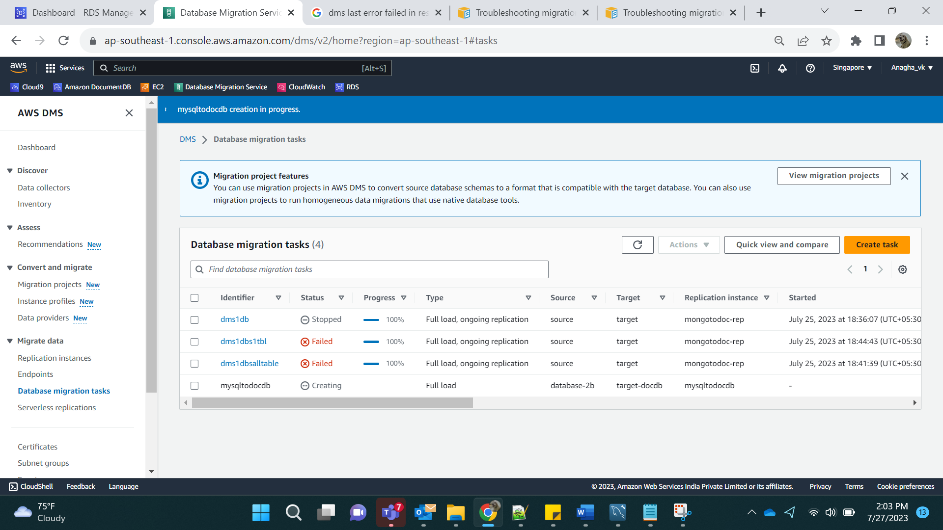

Result: we can see 1 database, all tables.

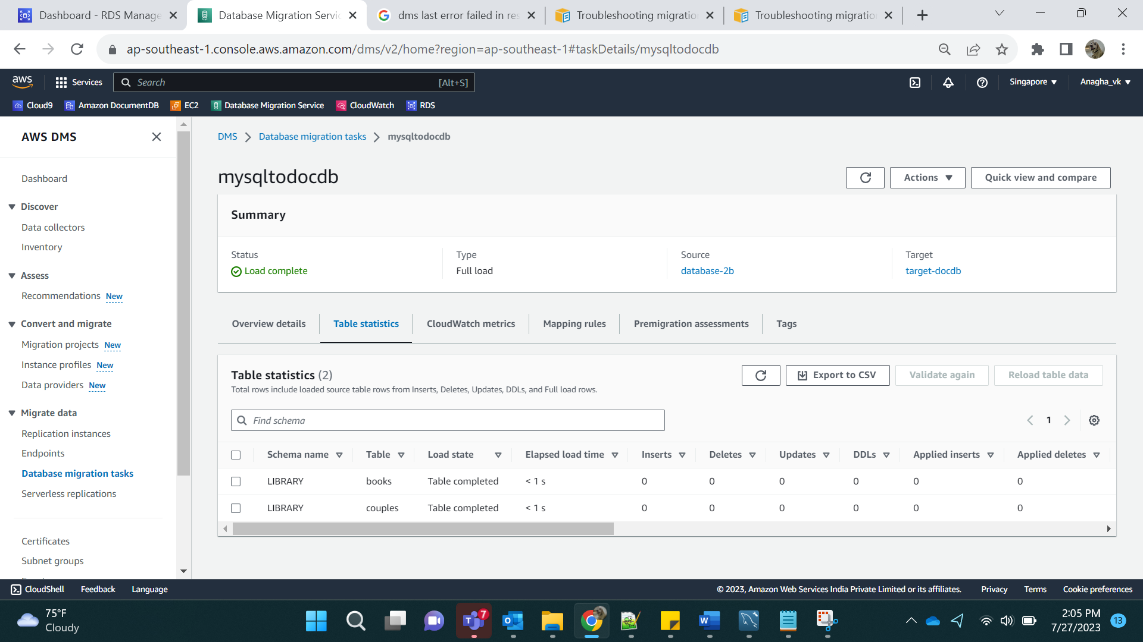

Scenario 2:

1 database, 1 table:

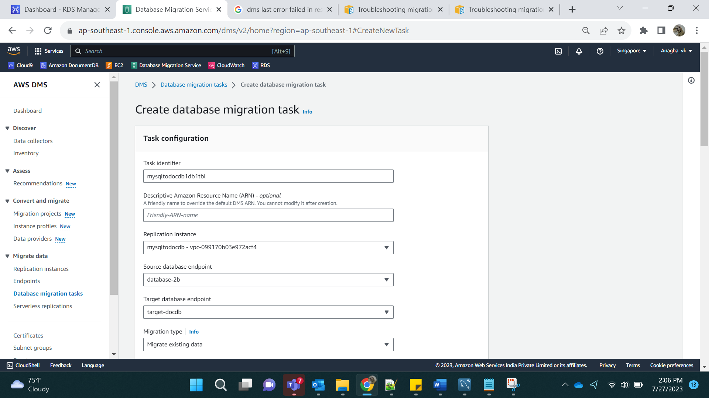

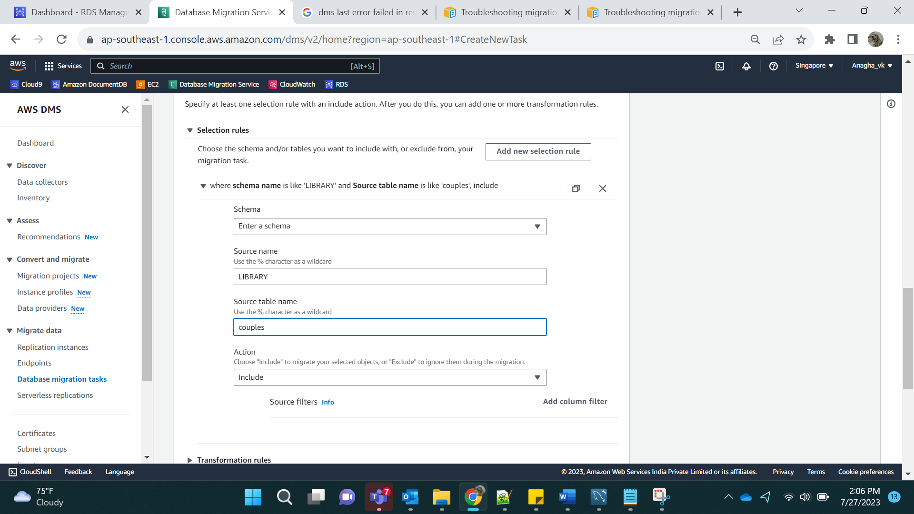

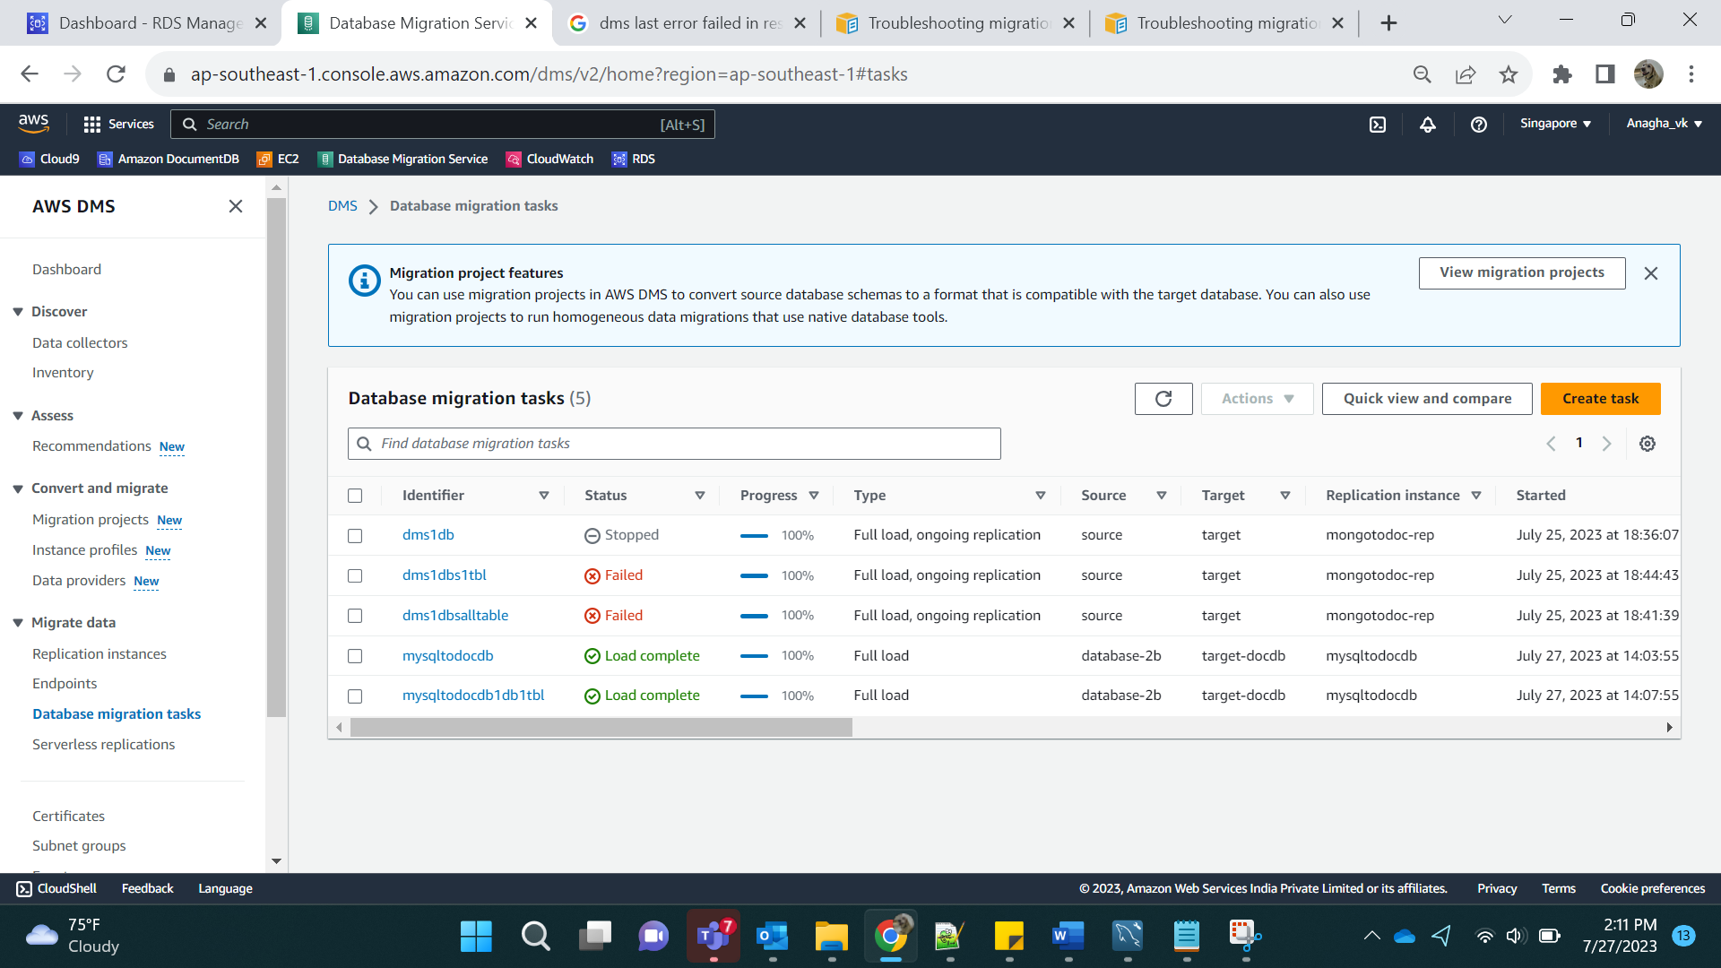

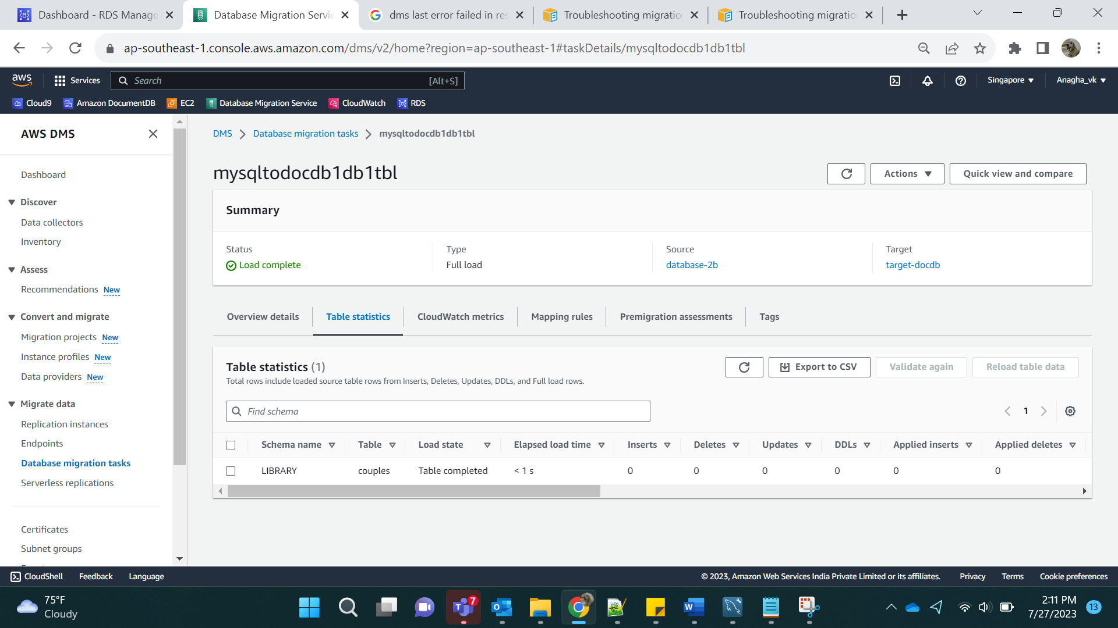

All DB:

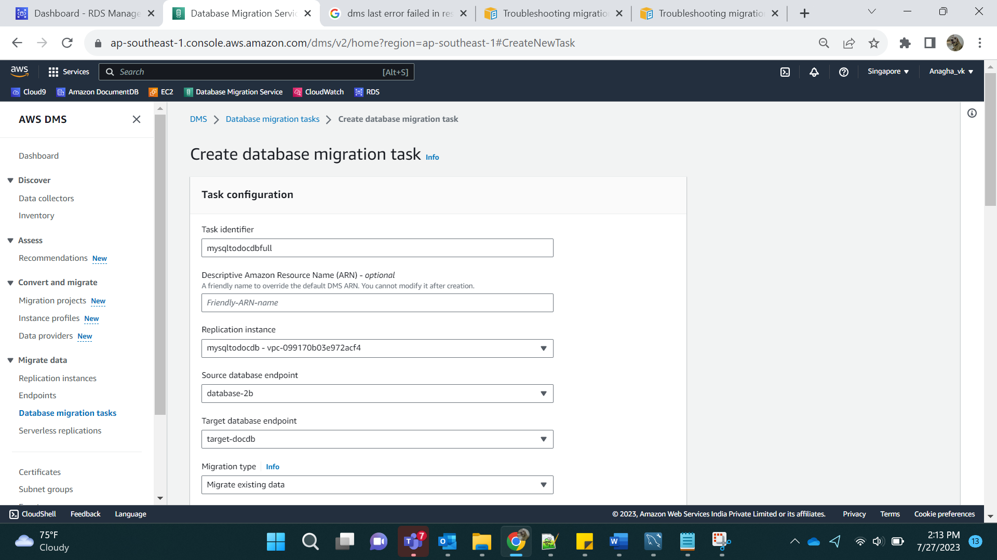

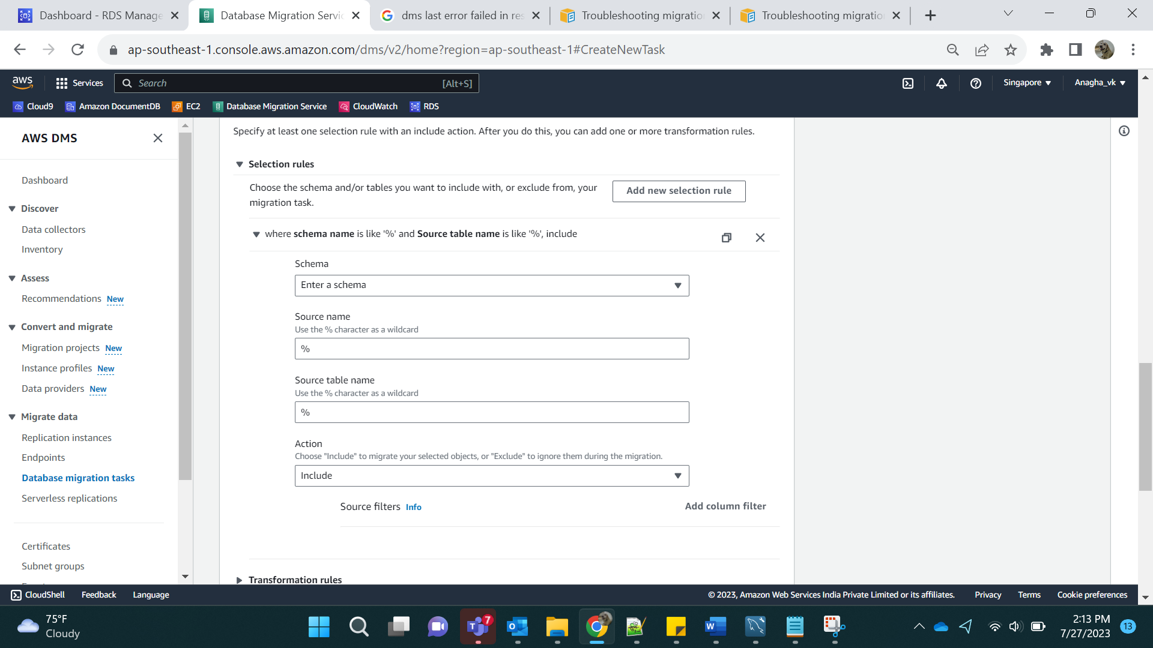

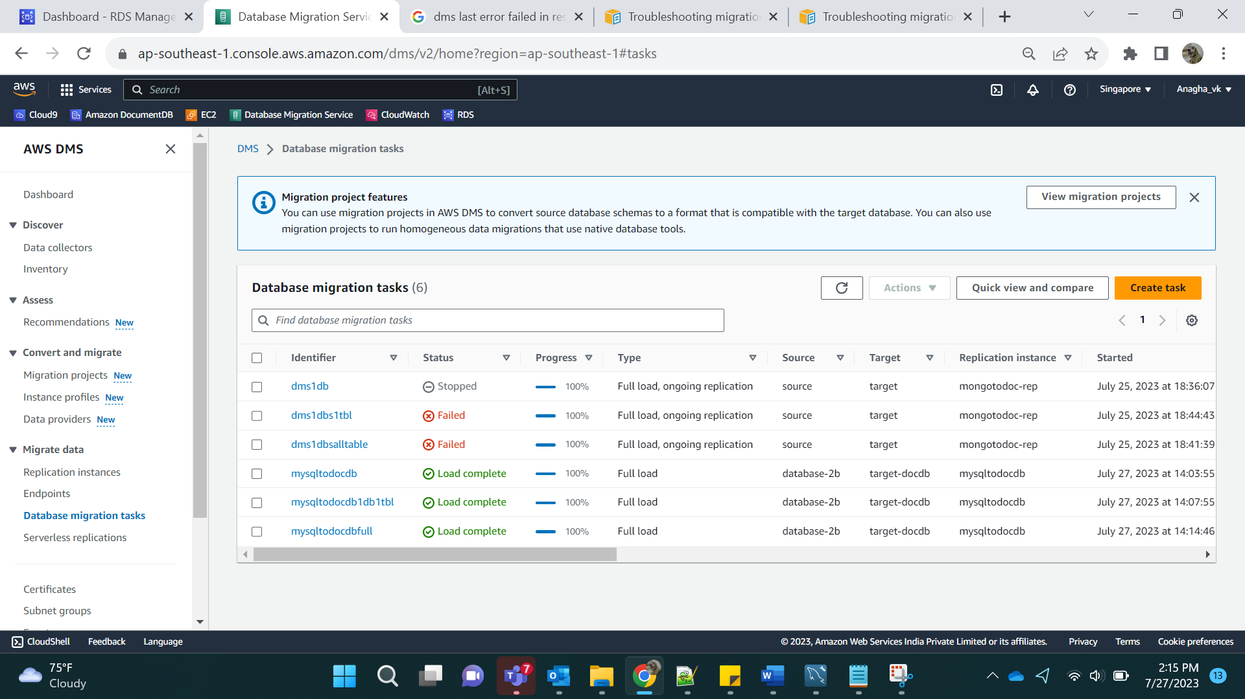

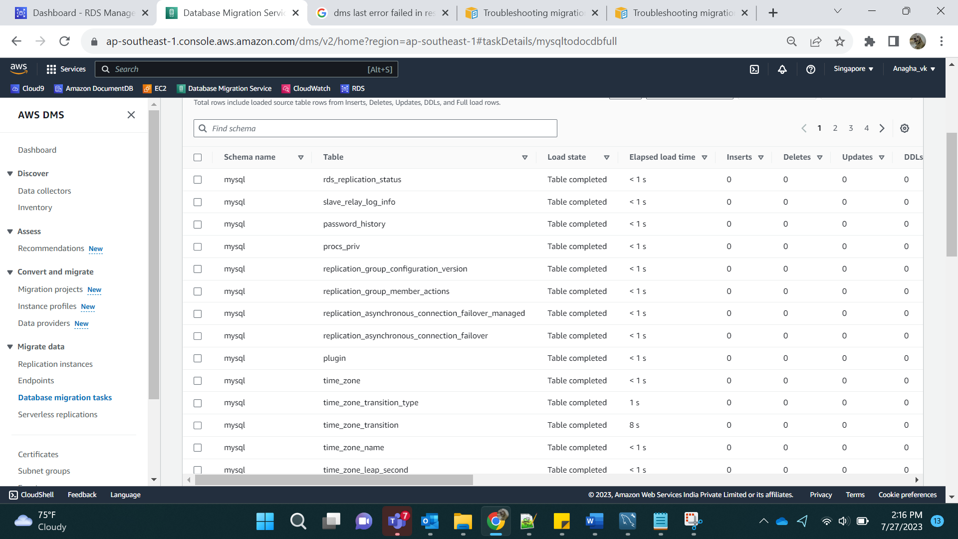

Highlighted tables are the one that I have created.

